Dear Parents / Carers,
We warmly invite you to join us for our First Holy Communion Mass, where we will come together in prayer, thanksgiving, and joy as a school family. This is a significant moment in the spiritual journey of our children, and we feel privileged to walk alongside them.
Event: First Holy Communion Mass
Date: Monday 22nd June
Venue: St. Cuthbert’s School Hall
Time: 11:00 – 11:45am
Arrangements for the day:
- Children should attend school at usual time 8:45am.
- Children are welcome to attend in their Holy Communion outfits.
- School photographer will be onsite to photograph the children.
- Please send in Summer Uniform for after the Mass for children to change.
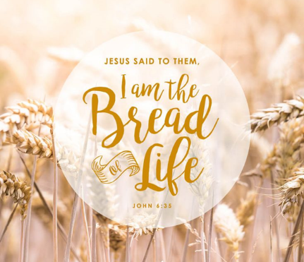
We are so proud of the children as they prepare with reverence and understanding. Please continue to keep them in your thoughts and prayers during this meaningful time.
Thank you for your continued support and partnership.
Kind regards,
Mr Brophy

