News article

Children’s and Young Peoples Immunisation summer drop-in clinic
Has your son or daughter missed any of their routine immunisations at their GP or in school?
Over the summer holidays, Mersey Care’s School Immunisation Team will be hosting a series of weekly catch up clinics offering children and young people in Liverpool, St Helens, Sefton and Knowsley any childhood and school immunisations they may have missed.

These catch up clinics will be held at various locations, please visit our web page for more information www.merseycare.nhs.uk/our-services/liverpool/vaccination-and-immunisation

All routine childhood immunisations will be available at these catch up clinics

The clinics will be offered on a drop-in basis – no appointment is needed, and children will be seen on a first come, first served basis.

Nikki Wilinski, Operational Manager for School Aged Immunisations at Mersey Care NHS Foundation Trust said:

“It’s vital that childhood vaccines are given on time as this provides your child with the best possible protection against diseases – but it’s never too late to catch up and ensure your child is protected especially now as we are seeing increasing cases of children with Measles and Whopping Cough.”

The summer holidays are an ideal time for parents / carers to catch up any missed immunisations and ensure your child is fully protected before they return to school in September.”

If you are unsure whether your child is up to date with their childhood immunisations, you can check this by contacting your GP or your local School Aged Immunisation Team on:

Liverpool Schools: 0151 295 3833 or email mcn-tr.vacandimms.team@nhs.net
Knowsley Schools: 0151 351 8805 or email mcn-tr.knowsleyimmunisationteam@nhs.net
Sefton Schools: 0151 247 6130 or email mcn-tr.seftonimmunisationteam@nhs.net
St Helens Schools: 01744 415 645 or email mcn-tr.immssth@nhs.net

You can find more information about the NHS Childhood Immunisations Programme, and when each one is due by scanning the QR code or visiting NHS vaccinations and when to have them - NHS (www.nhs.uk)
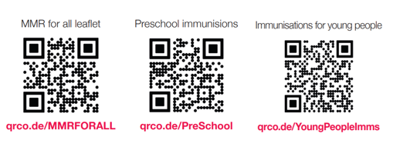

Matt Ashton, Director of Public Health for Liverpool City Council added:

“Thanks to the NHS Childhood Immunisation Programme, many dangerous and life-threatening diseases, such as polio, tetanus, diptheria, measles and mumps, have virtually disappeared in the UK.

“But they are still around in many other countries throughout the world – and in the UK, they are only kept at bay by our high immunisation rates. That’s why it’s so important that we all keep protecting our children with life-saving vaccines.

“If your child is not fully up to date on all of their immunisations and boosters, I would strongly urge you to take full advantage of these catch up clinics and get them fully protected.”

