Liverpool Children Centre’s
Healthy Lifestyle Programme
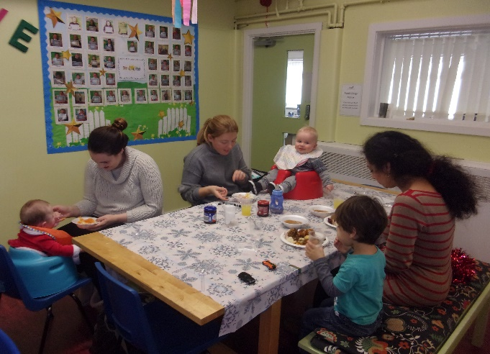
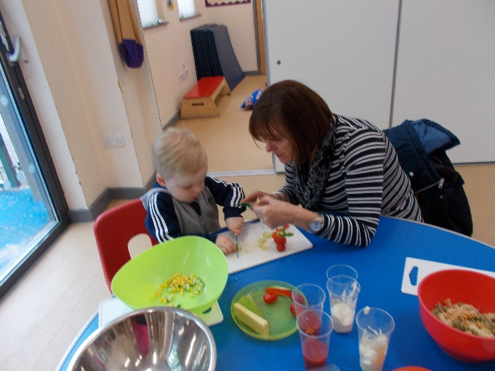

Do you have any worries about your Child’s eating habits, their diet or feeding?
Tracey our Healthy Weight Practitioner will be available at Stoney croft Children Centre on the 27th March
Between 10.00– 12.00pm
She can offer information and advice on:
- Fussy eating at mealtimes
- Restricted diet and only eating certain foods
- Making mealtimes enjoyable, removing the stress
- Children or Parents with anxieties around food
- How much food, portion sizes?
- Nutrition and the balance of food groups to provide to grow, develop and stay healthy
- How much physical activity does your child require?
Drop in or please call 0151 233 4770 to book an appointment.

