St. Cuthbert’s & St. Sebatian’s
Years 1 - 6 Reading Spine

Autumn 1
Year 1 | Year 2 | Year 3 | Year 4 | Year 5 | Year 6
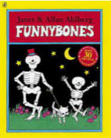  Funny Bones  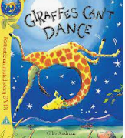  Giraffes Can’t Dance  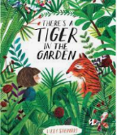  There’s a Tiger in the Garden  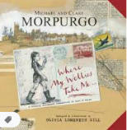  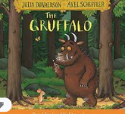  Where My Wellies Take Me  The Gruffalo  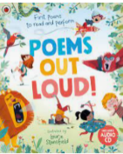  Poems out  Loud | 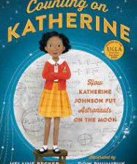  Counting on Katherine  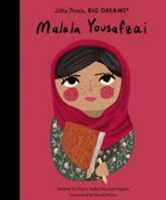  Little People, Big Dreams  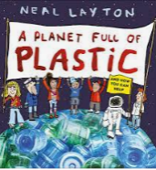  A Planet Full of Plastic  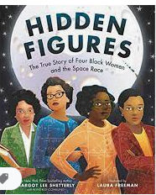  Hidden Figures | A Bear Called Paddington  by  Michael Bond | Why the Whales Came  by  Michael Morpurgo | Wicked World  by  Benjamin Zephaniah | Letters from the Lighthouse  by  Emma Carroll
 |  | 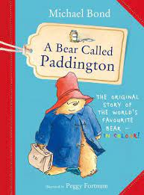 | 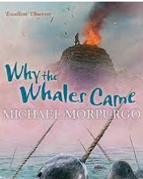 | 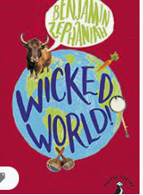 | 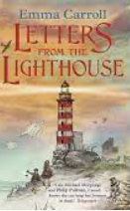
Autumn 2
Year 1 | Year 2 | Year 3 | Year 4 | Year 5 | Year 6
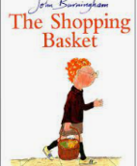  The Shopping Basket  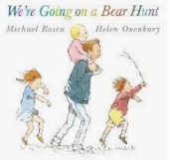  We’re Going on a Bear Hunt  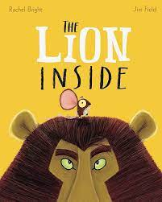  The Lion Inside  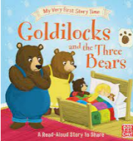  Goldilocks and the Three Bears  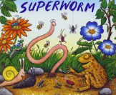  Superworm  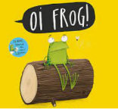  Oi Frog | The Owl Who Was Afraid of the Dark  by  Jill Tomlinson | The Wild Robot  by  Peter Brown | The Girl Who Stole an Elephant by  Nizrana Farook | The Storm Keeper’s Island  by  Catherine Doyle | Holes  by  Louis Sachar
 | 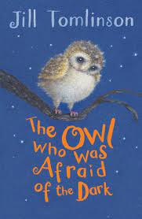 | 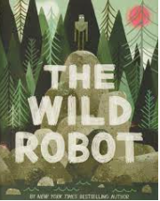 | 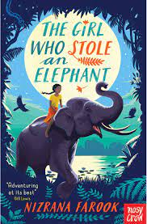 | 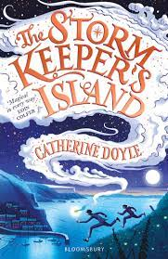 | 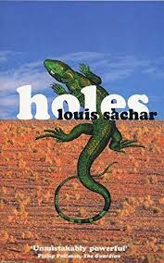

Spring 1
Year 1 | Year 2 | Year 3 | Year 4 | Year 5 | Year 6
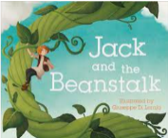  Jack and the Beanstalk  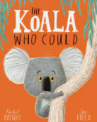  The Koala Who Could  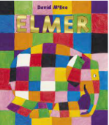  Elmer  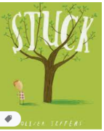  Stuck  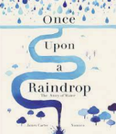  Once Upon A Raindrop | 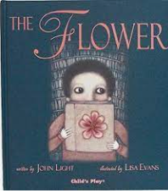  The Flower  by  John Light  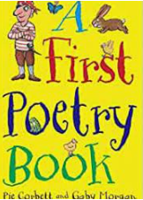  A First Poetry Book  by  Pie  Corbett | The Pebble In My Pocket  by  Meredith Hooper | Divers Daughter by  Patrice Lawrence | Wonder  by  R.J Palacio | War Horse  by  Michael Morpurgo
 |  | 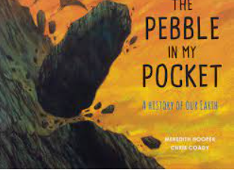 | 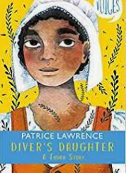 | 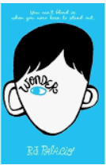 | 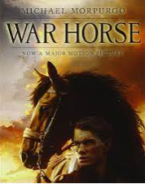
Spring 2
Year 1 | Year 2 | Year 3 | Year 4 | Year 5 | Year 6
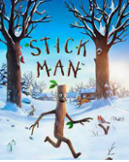  Stick Man  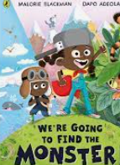  We’re Going to Find the Monster  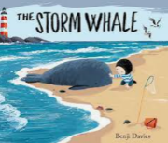  The Storm Whale  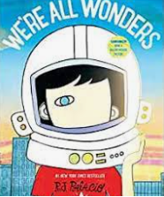  We’re all wonders  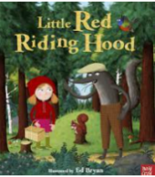  Little Red Riding Hood  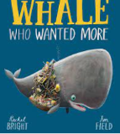  The Whale Who Wanted More | Charlotte’s Web  by  E.B White | Stig of the Dump by  Clive King | The Firework Makers Daughter  by  Philip Pullman | Happy Poems  by  Roger McGeogh | How the World Works  by  Christiane Dorion
 | 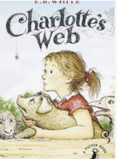 | 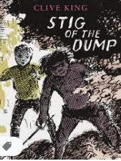 | 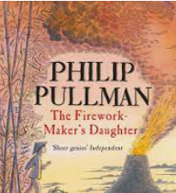 | 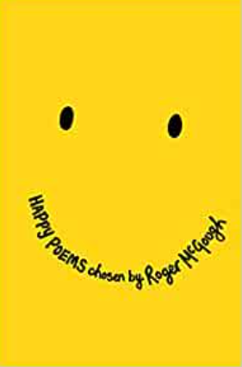 | 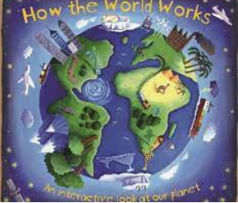

Summer 1
Year 1 | Year 2 | Year 3 | Year 4 | Year 5 | Year 6
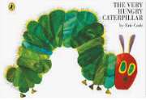  The Very Hungry Caterpillar  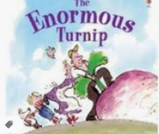  The Enormous Turnip  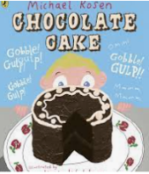  Chocolate Cake  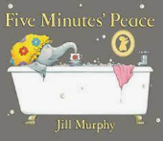  Five Minutes Peace  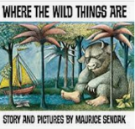  Where The Wild Things Are | Charlie and the Chocolate Factory by  Roald Dahl | Anisha :Accidental Detective  by  Serena Patel | Street Child  by  Berlie Doherty | The Lion above the Door  by  Onjali Q. Raúf | The Boy in the Tower  by  Polly Ho-Yen
 | 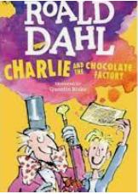 | 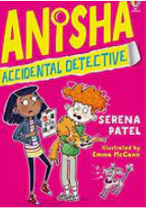 | 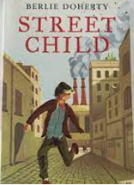 | 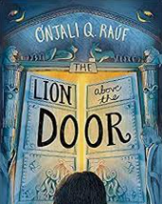 | 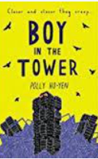
Summer 2
Year 1 | Year 2 | Year 3 | Year 4 | Year 5 | Year 6
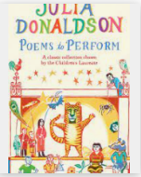  Julia Donaldson: Poems to Perform  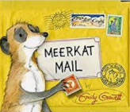  Meerkat Mail  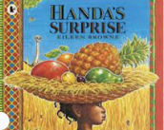  Handa’s Surprise  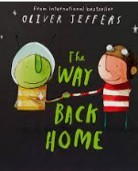  The Way Back Home  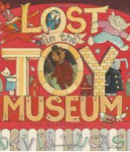  Lost in the Toy Museum | Betsey Biggalow by  Malorie Blackman | Poetry Pie  by  Roger McGeogh | Werewolf Club Rules  by  Joseph Coelho | The Explorer  by  Katherine Rundell | Shakespeare for Everyday of the Year  by  Allie Esiri
 | 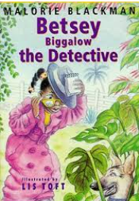 | 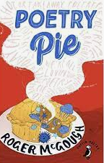 | 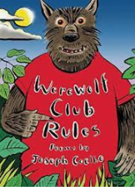 | 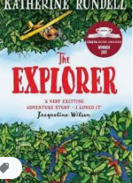 | 