Welcome to
St Cuthbert’s Catholic Primary School

Early Years Foundation Stage
2 Year Old Provision

St. Cuthbert’s Catholic Primary
School

Our Mission Statement

We the pupils, parents, and staff of St Cuthbert’s strive to create a caring, educational community where; Christian principles and standards are upheld, each person is valued and the spiritual, aesthetic and moral growth of individuals, as well as their intellectual and physical needs are met.

Contact Details
Address: St Cuthbert’s Catholic Primary School 30 Church Road Liverpool L13 2BA
Telephone Number: 0151 228 4137 (School Office)
Email address: cuthberts-ao@st-cuthberts.liverpool.sch.uk
Website: www.stcuthbertsliverpool.co.uk/
Session Times: 8.30 - 11.30am

Senior Leadership Team
Head Teacher: Mrs Claire Bellis-Knox
Assistant Head Teacher /DSL: Miss Angela Brough
Assistant Head Teacher/ SENCo: Mrs Kate Lunt
Senior Teacher/Curriculum: Miss Danielle Garvey
Learning Support Manager & DSL: Mrs Jackie Hilton
Business Manager: Mrs Lorraine Fay

Foundation Stage Team
EYFS Co-ordinator: Miss Angela Brough
Nursery Nurse: Ms Susanne Castro

Academic Year 2021/2022

Autumn Term 2021
- Starts: Wednesday 1st September (Inset Day children return 2nd September)
- Ends: Wednesday 22nd December
- Half term: Monday 25th October to Friday 29th October
- Christmas break: Thursday 23rd December to Tuesday 4th January

Spring Term 2022
- Starts: Wednesday 5th January
- Ends: Friday 8th April
- Half term: Monday 21st February to Friday 25th February
- Easter break: Monday 11th April to Friday 9th April

Summer Term 2022
- Starts: Monday 25th April
- Ends: Monday 18th July
- May day: Monday 2nd May
- Half term: Monday 30th May to Friday 3rd June

189 DAYS WITH 5 INSET DAYS TO BE SET
Extra bank holiday for the Queen’s Platinum Jubilee (Friday 3rd June 2022) falls within the May Half Term so the day will be taken at the end of term Tuesday 19th July instead.

Settling In Process

Home visit
We carry out home visits before your child starts in the 2 Year Old Provision. This gives your child the opportunity to meet the Foundation staff in the safety and comfort of their own home. It also gives us the opportunity to get to know your child, their medical history, their level of need and their interests, also to discuss your child’s 2 year old check (completed by your Health Visitor). Your child’s allocated session will be confirmed during the home visit and your child’s settle in date will also be agreed.

First day
Entry into the Foundation Stage setting is staggered in our 2 Year Old Provision which allows all children sufficient time to settle before new children start. On your child’s first day at nursery, you and your child will spend 1 hour together in the Unit. On this day parents will be asked to complete some forms – information about your child, contact details, consent forms etc. You will also have the opportunity to meet all the staff and raise any questions you may have.

Second day
On the second day your child will stay without you for 1 hour. If they are confident and happy in the Unit during this hour, they can attend the following day for the full session. If however, your child is particularly anxious or is experiencing difficulties, we will work with you to devise a settling in plan to suit the needs of your child until they feel more settled.

What we do to help the ‘Settling in Process’
- Home visits
- Staggered entry – only two children will start during any given session allowing children to explore the setting in a positive and non-threatening manner.
- Each child will be given a ‘Key Person’ who will be the constant for your child and do all they can to help them settle in. The ‘Key Person’ will speak to you, the parents, on a regular basis to keep you informed of your child’s adjustment to school life.
- Get to know your child and their interests so that we can plan activities that will engage them thereby making their time in the unit as positive as possible. We want to ensure that your child looks forward to attending nursery and fully embraces attending school.
- Each session follows a similar routine so that the children adjust to nursery life as quickly as possible.

What you can do to help the Settling in Process

- Before your child starts school, talk to them about what will happen and show them the pictures from this booklet.
- Explain that they will be coming to school each day and that you will leave them to have fun with their friends and return to collect them at home time.
- Be patient with the settling in process, sometimes it may take longer than you had hoped.
- Please try to hide any anxieties you may have about leaving your child, as any upset you may express will result in further uncertainty for your child.
- Always collect your child on time, they will be waiting for you and may become anxious as they see other children being collected by their parents.

Daily Routine
Morning Session

8.30am: Continuous Provision (Child Initiated Time)
Child initiated play – children are encouraged to explore all areas within the unit and access the different provisions independently or with adult support.

9.15am: Circle Time
The children come together on the carpet and sing a morning prayer, discuss the weather, find their own name and place in the basket. They will then follow a short adult led input in accordance with the Early Years Foundation Stage Curriculum. This helps them to develop a level of concentration for a short period of time.

9.40am: Continuous Provision (Child Initiated Time)
This is the time of the day where the children choose what activities/resources they want to explore. It is during this time that practitioners observe and take time to extend the child’s skills and knowledge based on the child’s interests.

11.00am: Key Person Time
Small group session following the children’s interests. Story time/ Spanish/ Singing/ Nursery Rhymes/ Number rhymes/basic skills etc…

11.30am: Home time
Please collect your child from the Foundation Stage Gate. Please be patient as children will be released to parents one at a time ensuring a safe handover. Please ensure that the person collecting your child is aged 16 or older and has been included on your Data Collection Form. If in the case of an emergency an adult (other than those listed on your Data Collection form) are required to collect your child, please ring the school office with their name, their relationship to your child and a password that they will be asked for upon collection of your child. If the person collecting is unable to recall the password, we will call you for verbal authorisation.

Please keep us updated of:
- Change of address or telephone number, in particular mobile phone numbers.
- Changes to the named people on the collection form.
- Change of emergency contact numbers.

Attendance
Every child has the right to attend school every day. Frequent and unnecessary absence has a detrimental effect on children’s academic education and social and emotional development. The expected level of attendance nationally is 97% and above. Attendance levels that fall below 95% are considered to be a cause for concern and will be referred to the Education Welfare Service for investigation.

Everyone associated with our federation has the responsibility to ensure that our children attend school regularly. The Federation Attendance Officer will monitor registers across both sites every day and may visit the homes of those children who are absent without explanation. The Education Welfare Office will monitor the attendance of children. Those whose attendance falls below 90% are considered to be persistent absentees and may be subject to a penalty notice.

Please make sure that:-
- Your child attends school regularly and on time.
- You contact school by 9.15am if your child is too sick to come to school. The contact number is 0151 228 4137
- You are able to provide proof of illness if your child is absent. This could be a Doctors’ note, medicine bottle with your child’s name on it or copy of a prescription.
- You keep school informed (in confidence) if there are difficult circumstances at home.
- You should keep your contact details up to date in the school office.
- You make dental/medical appointments outside school time if possible otherwise appointment letters and cards must be shown to school.
- You DO NOT TAKE HOLIDAYS IN TERM TIME. Parents who take children on holiday in term time will receive a fine from the Local Authority.
- You help school in our aim to improve attendance.
The school will:
- Inform parents regularly if their child’s attendance is giving cause for concern.
- Aim to support families who are experiencing difficulties.
- Refer families requiring support to the Education Welfare Officer.
- Inform the Education Welfare Officer of any pupil absent for five or more school days. If there are safeguarding issues this will be two days.
- Invite parents/pupils to meet with governors to formally agree improvements in the form of a contract.
- Use Penalty Notices via Education Welfare when necessary.
- Delete a child’s name from the school register only when it is clearly known that the child has moved to another school. This must be confirmed by the receiving school.
- Challenge the parents of those children in Foundation 1 who have poor attendance. These parents may be asked to reconsider their place in the unit.
- Promote the importance of good attendance.
- Recognise and reward good attendance throughout the school with weekly assemblies, termly and annual prizes, medals and certificates.
Medication
If your child requires medication during school hours, a Senior Member of Staff will oversee the administration of it but it must be prescribed by a doctor and have a label stating:
- Child’s name
- Date
- Expiry Date
- Dose
- Frequency
An adult must hand the medication to an adult. Please DO NOT leave medication of any kind in the possession of our child. 1pj[nPlease complete the Pupil Medical and Welfare Form

Foundation Stage Uniform
(available from Swan School Wear on Broadgreen Rd)
Winter Uniform
- Royal blue round neck sweatshirt with white stitched Foundation Unit
- Royal blue jogging bottoms
- White polo shirt
- Trainers or pumps with Velcro fastening (No Laces Please!)

Summer Uniform (optional)
- Royal blue shorts
- White polo top
- Trainers or pumps with Velcro fastening (No Laces Please!)
- Please note that due to the physical nature of the EYFS curriculum summer dresses are not permitted in the Foundation unit.

School Coat (optional)
- Black waterproof school coat with white stitched St. Cuthbert’s logo.

We also recommend that you leave a pair of wellington boots in the Foundation Unit for those muddy days.

Please ensure that your child’s name is on all of their uniform, book bag and/or lunch box.

Snack Time
We provide a healthy snack each day and have a designated snack area. We ask for a voluntary contribution of £1 per week to cover the costs of snack. Thank you in advance for your support with this.

Toys, sweets or money
We ask that you do not allow your child to bring in any sweets, toys or money from home. These can become damaged or lost and this often causes the child unnecessary distress.

Jewellery
As a safety precaution, the wearing of chains, necklaces, earrings, bracelets and rings is forbidden in the Unit as such items can easily catch on equipment and cause injury.
Children must cover pierced ears with plasters to prevent injury.

We ask that you do not allow your child to bring in any sweets, toys or money from home. These can become damaged or lost and this often causes the child unnecessary distress.

What is the Early Years Foundation Stage (EYFS)?

The Early Years Foundation Stage (EYFS) sets the standards that all early years’ providers must meet to ensure that children learn and develop well and are kept healthy and safe. It promotes teaching and learning to ensure children’s ‘school readiness’ and gives children the broad range of knowledge and skills that provide the right foundation for good future progress through school and life.

The EYFS seeks to provide:

• Quality and consistency in all early years settings, so that every child makes good progress and no child gets left behind.

• A secure foundation through planning for the learning and development of each individual child, and assessing and reviewing what they have learned regularly.

• Partnership working between practitioners and with parents and/or carers.

• Equality of opportunity and anti-discriminatory practice, ensuring that every child is included and supported.

EYFS Framework

There are seven areas of learning and development that shape educational programmes in early years settings. All areas of learning and development are important and inter-connected. Three areas are particularly important for building a foundation for igniting children’s curiosity and enthusiasm for learning, forming relationships and thriving. These are the prime areas: Personal, Social and Emotional Development (PSED), Communication and Language (C&L) and Physical Development (PD) - highlighted in green. Staff will also support children in four specific areas, through which the three prime areas are strengthened and applied. The specific areas are: Literacy Mathematics, Understanding the World, Expressive Arts and Design - highlighted in blue.

Play underpins the delivery of our Early Years education, in which the children have the opportunity to play indoors and outdoors. As a Foundation team we carefully plan a curriculum following the children’s interests. We have a balance of planned adult directed activities and child initiated activities as well as a diversely stimulating environment in which the children can explore and develop their understanding within the different areas of learning.

Personal, Social and Emotional Development

Children’s personal, social and emotional development (PSED) is crucial for children to lead healthy and happy lives, and is fundamental to their cognitive development. Underpinning their personal development are the important attachments that shape their social world. Strong, warm and supportive relationships with adults enable children to learn how to understand their own feelings and those of others. Children should be supported to manage emotions, develop a positive sense of self, set themselves simple goals, have confidence in their own abilities, to persist and wait for what they want and direct attention as necessary. Through adult modelling and guidance, they will learn how to look after their bodies, including healthy eating, and manage personal needs independently. Through supported interaction with other children they learn how to make good friendships, co-operate and resolve conflicts peaceably. These attributes will provide a secure platform from which children can achieve at school and in later life.

PSED is made up of these aspects:

Self-Regulation: Children at the expected level of development will: -Show an understanding of their own feelings and those of others, and begin to regulate their behaviour accordingly; - Set and work towards simple goals, being able to wait for what they want and control their immediate impulses when appropriate; - Give focused attention to what the teacher says, responding appropriately even when engaged in activity, and show an ability to follow instructions involving several ideas or actions.

Managing Self: Children at the expected level of development will: - Be confident to try new activities and show independence, resilience and perseverance in the face of challenge; - Explain the reasons for rules, know right from wrong and try to behave accordingly; - Manage their own basic hygiene and personal needs, including dressing, going to the toilet and understanding the importance of healthy food choices.

Building Relationships: Children at the expected level of development will: - Work and play cooperatively and take turns with others; - Form positive attachments to adults and friendships with peers; - Show sensitivity to their own and to others’ needs.

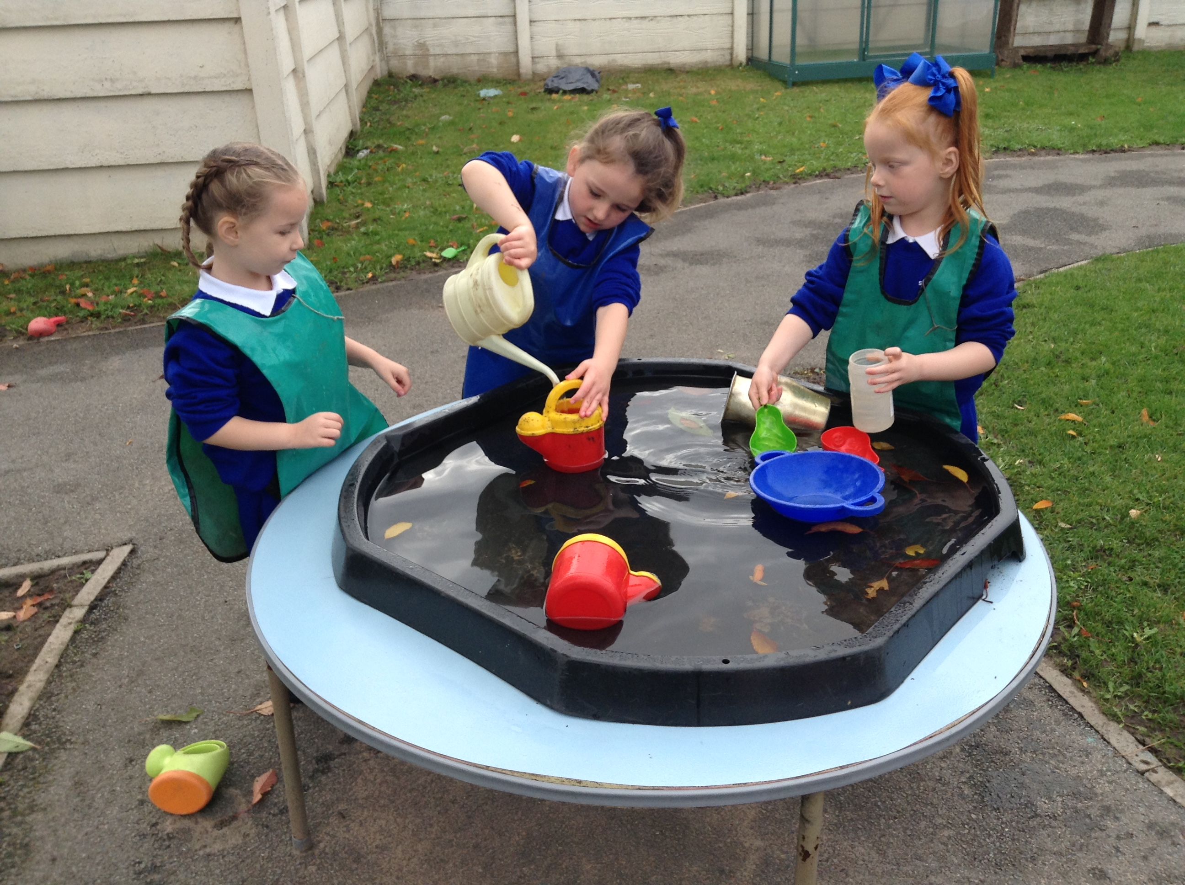

Communication and Language

The development of children’s spoken language underpins all seven areas of learning and development. Children’s back-and-forth interactions from an early age form the foundations for language and cognitive development. The number and quality of the conversations they have with adults and peers throughout the day in a language-rich environment is crucial. By commenting on what children are interested in or doing, and echoing back what they say with new vocabulary added, practitioners will build children's language effectively. Reading frequently to children, and engaging them actively in stories, non-fiction, rhymes and poems, and then providing them with extensive opportunities to use and embed new words in a range of contexts, will give children the opportunity to thrive. Through conversation, story-telling and role play, where children share their ideas with support and modelling from their teacher, and sensitive questioning that invites them to elaborate, children become comfortable using a rich range of vocabulary and language structures.

CL is made up of these aspects:

Listening, Attention and Understanding: Children at the expected level of development will: - Listen attentively and respond to what they hear with relevant questions, comments and actions when being read to and during whole class discussions and small group interactions; - Make comments about what they have heard and ask questions to clarify their understanding; - Hold conversation when engaged in back-and-forth exchanges with their teacher and peers.

Speaking: Children at the expected level of development will: - Participate in small group, class and one-to-one discussions, offering their own ideas, using recently introduced vocabulary; - Offer explanations for why things might happen, making use of recently introduced vocabulary from stories, non-fiction, rhymes and poems when appropriate; Express their ideas and feelings about their experiences using full sentences, including use of past, present and future tenses and making use of conjunctions, with modelling and support from their teacher.

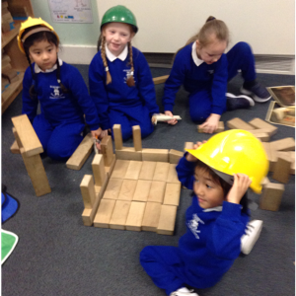

Physical Development

Physical activity is vital in children’s all-round development, enabling them to pursue happy, healthy and active lives. Gross and fine motor experiences develop incrementally throughout early childhood, starting with sensory explorations and the development of a child’s strength, co-ordination and positional awareness through tummy time, crawling and play movement with both objects and adults. By creating games and providing opportunities for play both indoors and outdoors, adults can support children to develop their core strength, stability, balance, spatial awareness, co-ordination and agility. Gross motor skills provide the foundation for developing healthy bodies and social and emotional well-being. Fine motor control and precision helps with hand-eye co-ordination which is later linked to early literacy. Repeated and varied opportunities to explore and play with small world activities, puzzles, arts and crafts and the practice of using small tools, with feedback and support from adults, allow children to develop proficiency, control and confidence

PD is made up of these aspects:

Gross Motor Skills: Children at the expected level of development will: - Negotiate space and obstacles safely, with consideration for themselves and others; - Demonstrate strength, balance and coordination when playing; Move energetically, such as running, jumping, dancing, hopping, skipping and climbing.

Fine Motor Skills: Children at the expected level of development will: - Hold a pencil effectively in preparation for fluent writing – using the tripod grip in almost all cases; - Use a range of small tools, including scissors, paint brushes and cutlery; - Begin to show accuracy and care when drawing.

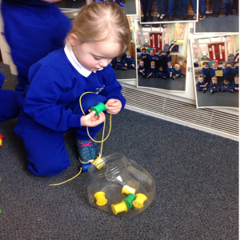

Literacy

It is crucial for children to develop a life-long love of reading. Reading consists of two dimensions: language comprehension and word reading. Language comprehension (necessary for both reading and writing) starts from birth. It only develops when adults talk with children about the world around them and the books (stories and non-fiction) they read with them, and enjoy rhymes, poems and songs together. Skilled word reading, taught later, involves both the speedy working out of the pronunciation of unfamiliar printed words (decoding) and the speedy recognition of familiar printed words. Writing involves transcription (spelling and handwriting) and composition (articulating ideas and structuring them in speech, before writing)

LD is made up of these aspects:

Comprehension: Children at the expected level of development will: - Demonstrate understanding of what has been read to them by retelling stories and narratives using their own words and recently introduced vocabulary; - Anticipate – where appropriate – key events in stories; - Use and understand recently introduced vocabulary during discussions about stories, non-fiction, rhymes and poems and during role-play.
Word Reading: Children at the expected level of development will: - Say a sound for each letter in the alphabet and at least 10 digraphs; - Read words consistent with their phonic knowledge by sound-blending; - Read aloud simple sentences and books that are consistent with their phonic knowledge, including some common exception words.
Writing: Children at the expected level of development will: - Write recognisable letters, most of which are correctly formed; - Spell words by identifying sounds in them and representing the sounds with a letter or letters; Write simple phrases and sentences that can be read by others.

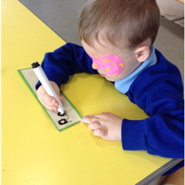
.

Mathematics

Developing a strong grounding in number is essential so that all children develop the necessary building blocks to excel mathematically. Children should be able to count confidently, develop a deep understanding of the numbers to 10, the relationships between them and the patterns within those numbers. By providing frequent and varied opportunities to build and apply this understanding - such as using manipulatives, including small pebbles and tens frames for organising counting - children will develop a secure base of knowledge and vocabulary from which mastery of mathematics is built. In addition, it is important that the curriculum includes rich opportunities for children to develop their spatial reasoning skills across all areas of mathematics including shape, space and measures. It is important that children develop positive attitudes and interests in mathematics, look for patterns and relationships, spot connections, ‘have a go’, talk to adults and peers about what they notice and not be afraid to make mistakes. .

Mathematics is made up of these aspects:

Number: Children at the expected level of development will: - Have a deep understanding of number to 10, including the composition of each number; - Subitise (recognise quantities without counting) up to 5; - Automatically recall (without reference to rhymes, counting or other aids) number bonds up to 5 (including subtraction facts) and some number bonds to 10, including double facts.

Numerical Patterns: Children at the expected level of development will: - Verbally count beyond 20, recognising the pattern of the counting system; - Compare quantities up to 10 in different contexts, recognising when one quantity is greater than, less than or the same as the other quantity; - Explore and represent patterns within numbers up to 10, including evens and odds, double facts and how quantities can be distributed equally.
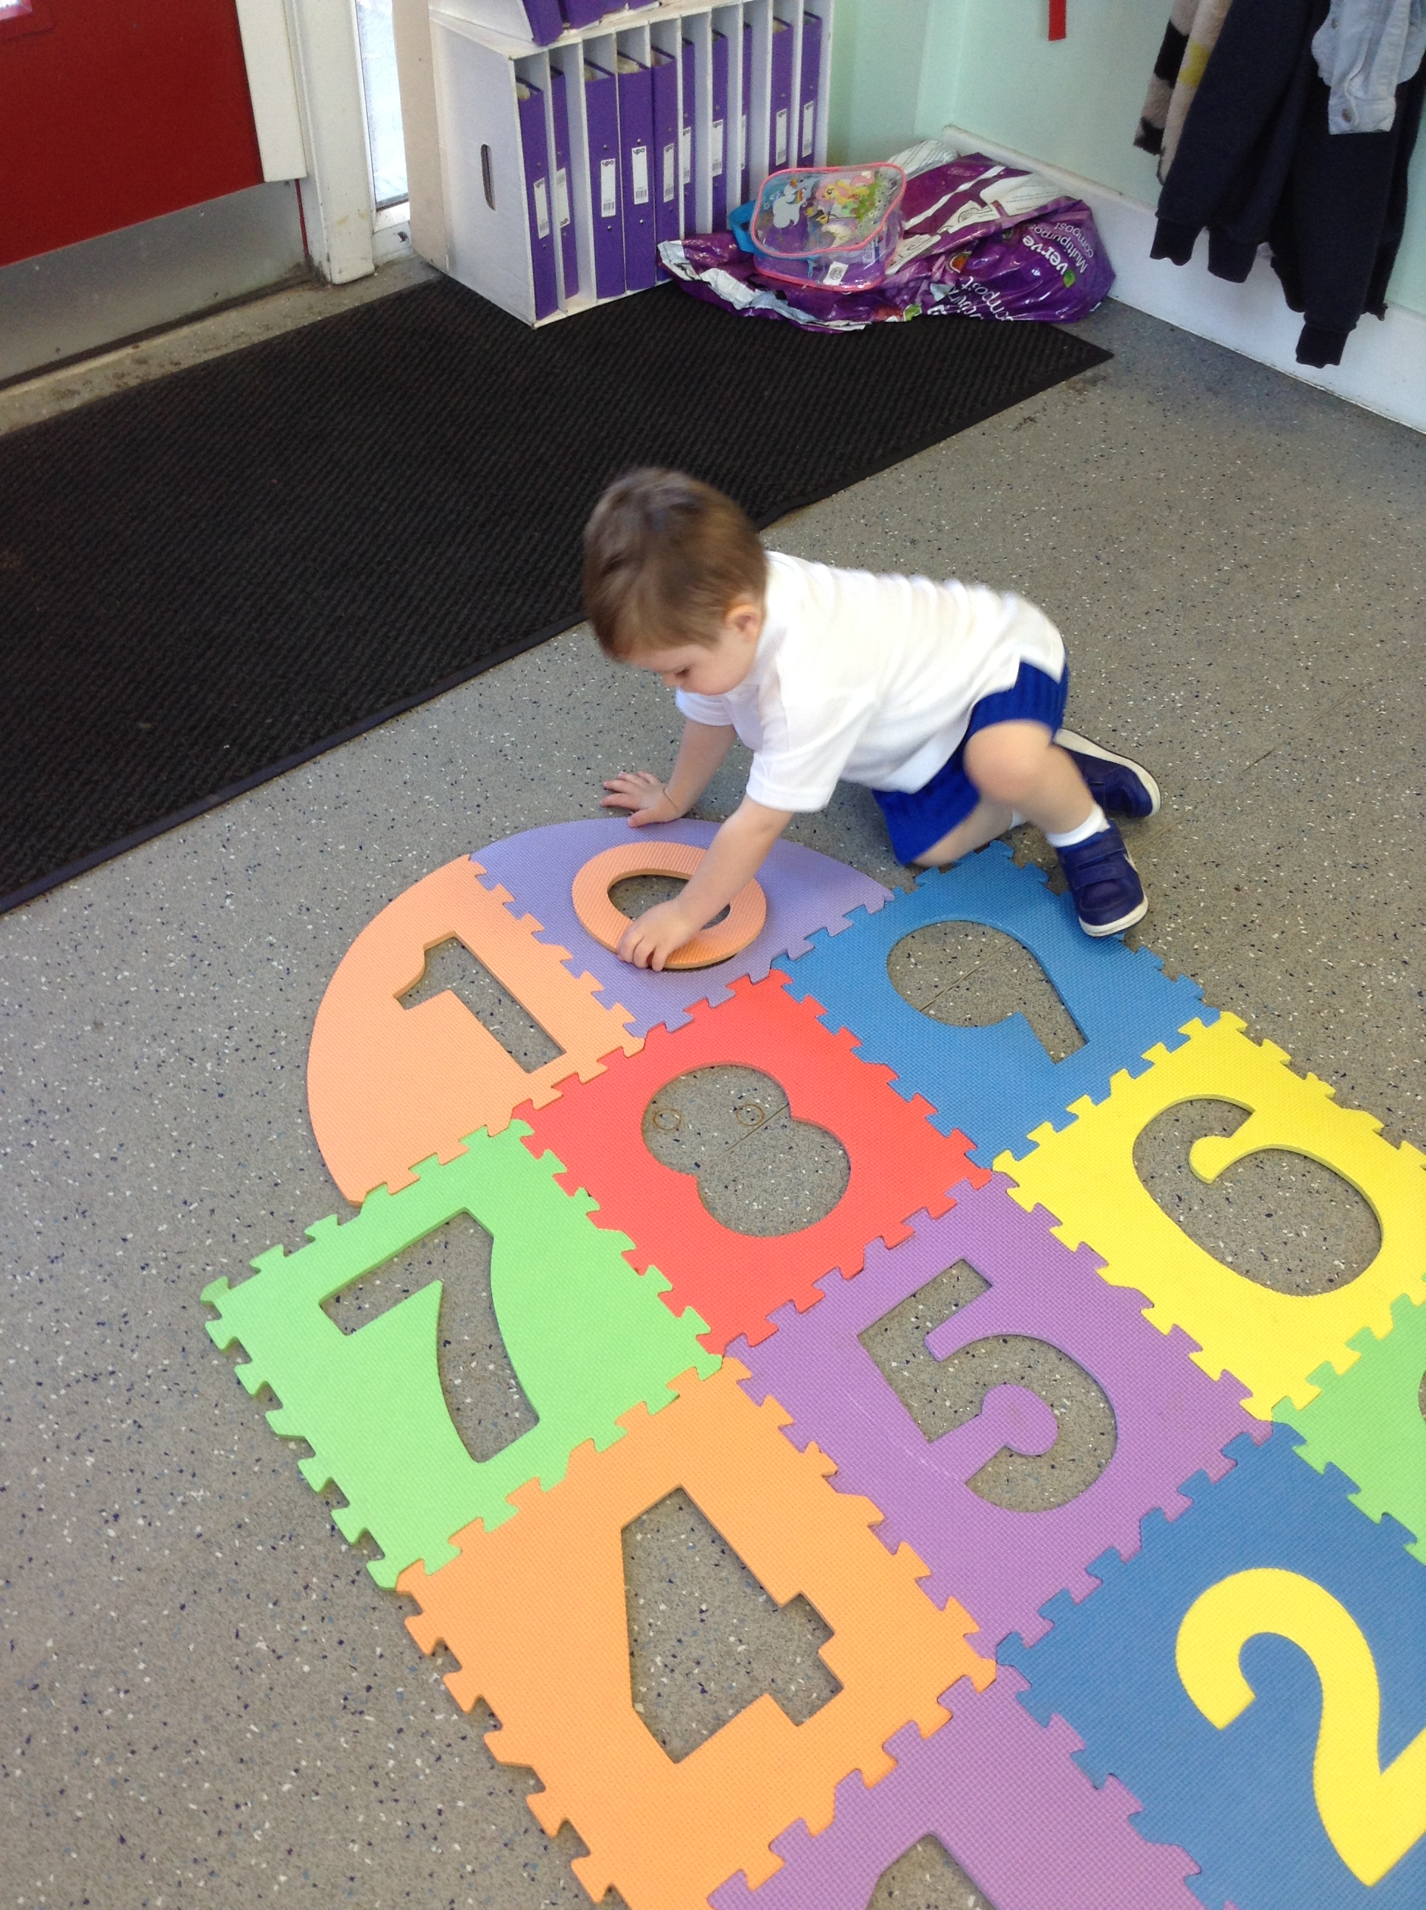

Understanding the World

Understanding the world involves guiding children to make sense of their physical world and their community. The frequency and range of children’s personal experiences increases their knowledge and sense of the world around them – from visiting parks, libraries and museums to meeting important members of society such as police officers, nurses and firefighters. In addition, listening to a broad selection of stories, non-fiction, rhymes and poems will foster their understanding of our culturally, socially, technologically and ecologically diverse world. As well as building important knowledge, this extends their familiarity with words that support understanding across domains. Enriching and widening children’s vocabulary will support later reading comprehension.

UW is made up of these aspects:

Past and Present: Children at the expected level of development will: - Talk about the lives of the people around them and their roles in society; - Know some similarities and differences between things in the past and now, drawing on their experiences and what has been read in class; - Understand the past through settings, characters and events encountered in books read in class and storytelling.

People, Culture and Communities: Children at the expected level of development will: - Describe their immediate environment using knowledge from observation, discussion, stories, non-fiction texts and maps; Know some similarities and differences between different religious and cultural communities in this country, drawing on their experiences and what has been read in class; - Explain some similarities and differences between life in this country and life in other countries, drawing on knowledge from stories, non-fiction texts and – when appropriate – maps.

The Natural World: Children at the expected level of development will: - Explore the natural world around them, making observations and drawing pictures of animals and plants; - Know some similarities and differences between the natural world around them and contrasting environments, drawing on their experiences and what has been read in class; - Understand some important processes and changes in the natural world around them, including the seasons and changing states of matter.

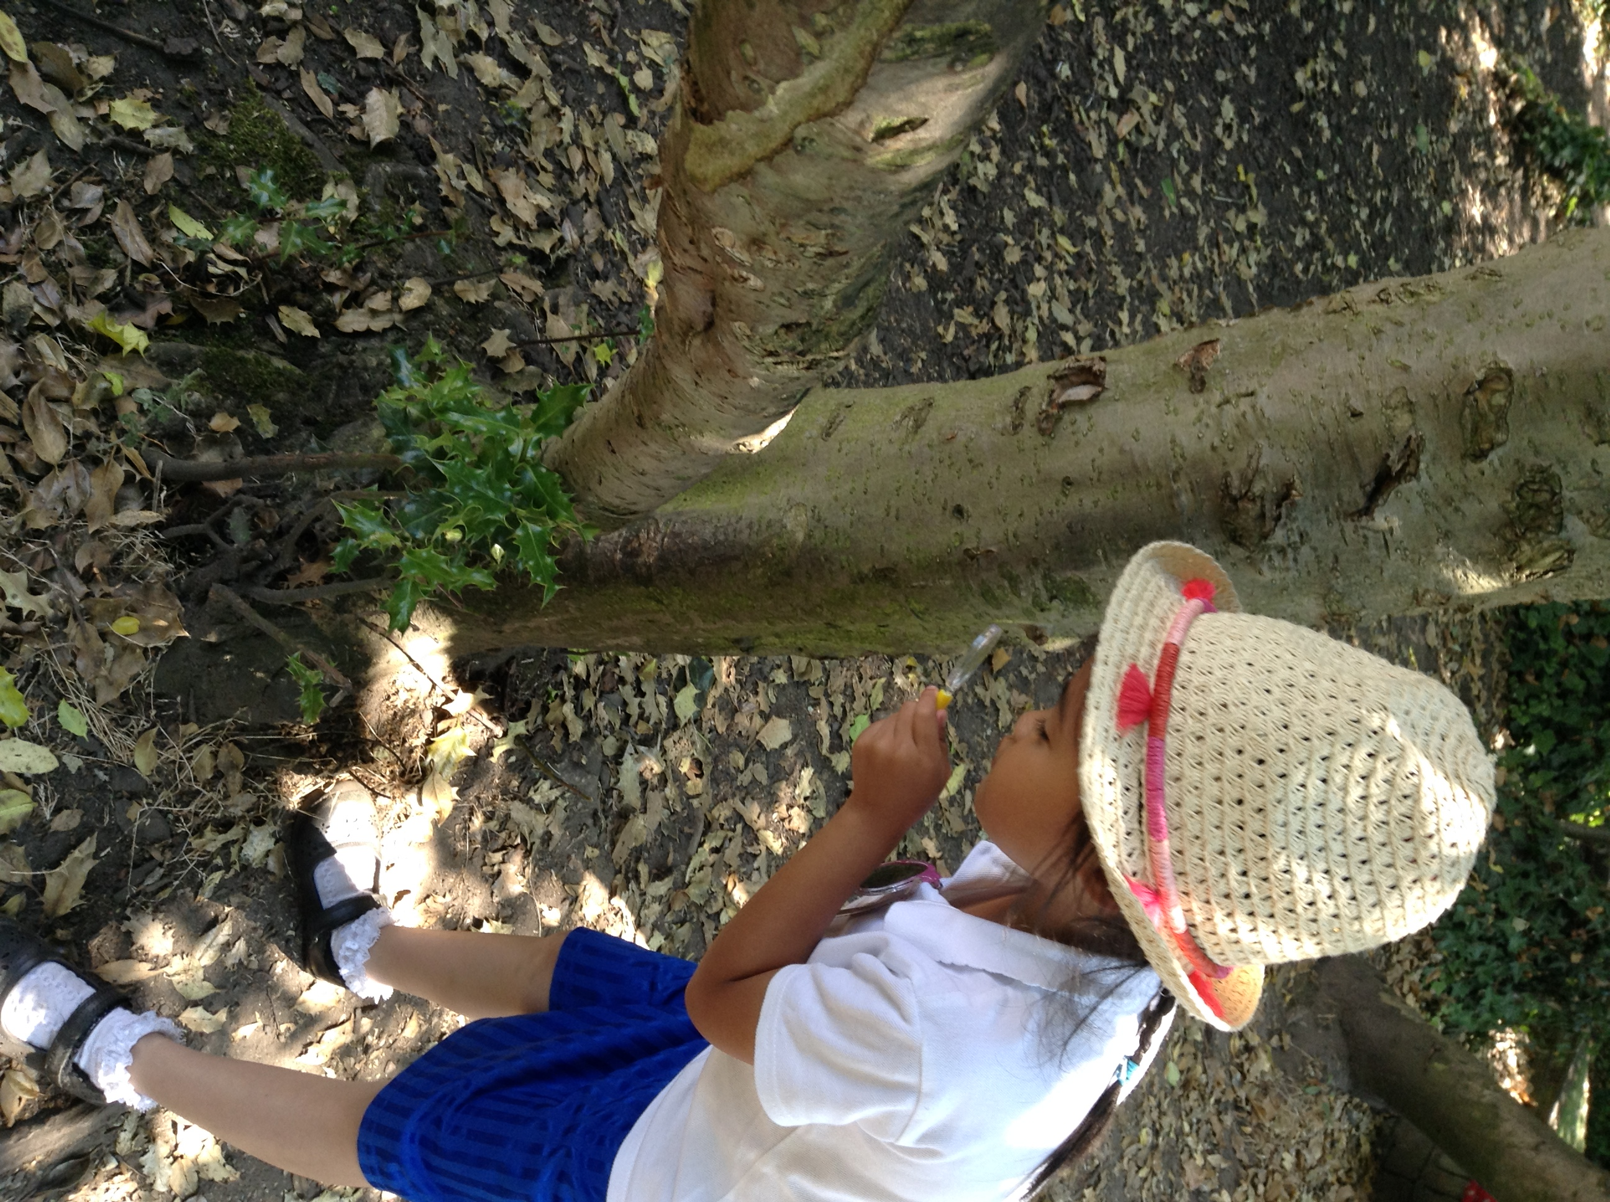

Expressive Arts and Design

The development of children’s artistic and cultural awareness supports their imagination and creativity. It is important that children have regular opportunities to engage with the arts, enabling them to explore and play with a wide range of media and materials. The quality and variety of what children see, hear and participate in is crucial for developing their understanding, self-expression, vocabulary and ability to communicate through the arts. The frequency, repetition and depth of their experiences are fundamental to their progress in interpreting and appreciating what they hear, respond to and observe.

EAD is made up of these aspects:

Creating with Materials: Children at the expected level of development will: - Safely use and explore a variety of materials, tools and techniques, experimenting with colour, design, texture, form and function; - Share their creations, explaining the process they have used; - Make use of props and materials when role playing characters in narratives and stories.

Being Imaginative and Expressive: Children at the expected level of development will: - Invent, adapt and recount narratives and stories with peers and their teacher; - Sing a range of well-known nursery rhymes and songs; Perform songs, rhymes, poems and stories with others, and – when appropriate – try to move in time with music.

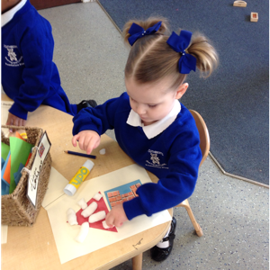

Key Person Role

We have a Key Person system in place which has proved to be extremely effective for all of the children and their families. Every child in Foundation 2 will have a Key Person. Your child will meet with their group regularly. During this time the children will be given the opportunity to reflect on their sessions work, share news, talk about special events that have happened, share a story or sing some songs/nursery rhymes. This also allows a smaller group of children to get to know each other better and also establish a closer relationship with their Key Person. If your child has done something special or would like to share something special please speak to your child’s Key Person who can share this at small group time.

There are also opportunities throughout the year to meet with your child’s Key Person to discuss your child’s progress. If you wish to speak to your child’s Key Person regarding something in particular please arrange an appointment through the office. In order to ensure child safety due to it being a busy time with children entering and leaving the unit at the beginning and end of their session, please be prepared to stand back and wait a few moments, staff will be unable to answer questions at this time. If you wish you may stand to one side until all of the children have been safely collected by their parents and then a member of staff will be able to help you.

We do also use ClassDojo. This is an app that you can download onto your phone and message your child's teacher directly. Further information on how to do this will be given to you when your child starts Foundation.

We will strive to ensure good relations between ourselves and you in order to keep the lines of communications open at all times. We value your opinion, views and input as the child’s first educator, however should you have any concerns no matter how small please do not hesitate to speak to us to relieve any worries. Minor issues can usually be resolved by your child's teachers. If you do have any unresolved issues or complaints, please contact Mrs C Bellis-Knox, Miss A Brough or Mrs J Hilton by phoning or writing to the school.

Home/School Links

We recognise the importance of fostering a good relationship between us, the school, and you, the parents/guardians and we continually strive to ensure good relations between both parties. We value your opinion, views and input as your child’s first educator and think it best for all parties concerned if the lines of communication are open at all times. We therefore operate an ‘open door policy’ and suggest that if you do have any questions, queries or concerns, no matter how small, that you speak to a member of staff. We are always happy and willing to listen to you about any and all matters. Most issues can generally be dealt with by the Foundation staff however, if you have a complaint please contact Mrs C Bellis-Knox, Miss A Brough or Mrs J Hilton by phoning or writing to the school.

What we do to promote good home/school relationships

Newsletters – A newsletter will be sent home every half term to keep you informed of any events, activities, inset days etc.

School Website – (stcuthbertsliverpool.co.uk) The school website contains information of any upcoming events, holiday dates or recent activities pertaining to our school.

ClassDojo app - After your child has begun school, you will be given a log in for our classdojo app explaining how to access it on your phone. This has proven to be an excellent way for parents to keep up to date with what's going on and it allows you to contact their class teacher directly. Teachers will strive to respond to any messages promptly however there may be a delay at times if they are teaching. They are only contactable during school hours, any messages sent outside of school hours will be answered during the next working day.

St Cuthbert’s Twitter Account – please add @StCuthbertsPri on Twitter for up to date information and events happening daily in school. You can also download our school app for news, information, term dates, payments etc.

Shared Learning Days – From time to time you will be invited into the Unit to take part in a ‘shared learning day’. These days give you, the parents, the opportunity to observe firsthand what we do in the setting and allows you to ‘share’ in the learning experience with your child.

Open evenings – Whilst you are welcome to access your child’s file of work at any time, we do allocate certain evenings during the term in which we invite you into the setting to peruse your child’s file of work and have a one to one chat with the Foundation staff regarding your child’s progress.

Star of the Week – If your child is nominated as our class ‘Star of the Week’ they will be invited to take our ‘Star Teddy’ home to your house for the weekend. We ask that as parents you help your child to draw/ write what they did with ‘Star Teddy’ at the weekend and your child will be invited to share their news with the rest of the group the following Monday.

St. Cuthbert’s Home Visit Policy

Childhood experiences lay the foundations for later life. Parenting has a critical impact on children’s emotional, behavioural and educational development, and their health and wellbeing. The school works in partnership with parents to ensure positive outcomes for children and the first step in this partnership is to home visit every family prior to the child coming to nursery (Foundation 1).

Two members of staff from the Foundation Stage Unit will carry out these visits, one of whom will be your child’s allocated key worker. Both members of staff will wear their I.D badges and carry a mobile phone left on throughout the visit, the number of which will be left in the school office. The safety of our staff is paramount and an informal risk assessment is carried out before entering the home of the family.

The address of the home visit is always left in the school diary located in the school office; also a member of the SMT (Senior Management Team) is aware of the visit taking place.

The key-worker will take along a Foundation 1 handbook and share any relevant information with the parents/carers, a home visit record sheet is completed during the home visit. The key worker will explain the settling in period with the parent and will find out the child’s favourite toys, interests and any other relevant family background information.

A period of half an hour will be allocated to each home visit. As part of our induction to the Foundation Stage, a home visit is carried out, however if a home visit is unsuitable the parent will be invited to visit the nursery at a mutually agreed time to meet the child’s key worker. An agreed start date is given at the visit and parents are asked to stay for one hour on this visit to complete all necessary paper work and contact details.

The Lead Practitioner (Jackie Hilton) may also carry out additional Home Visits throughout the year, to support families with varying needs (throughout the year). If these visits are undertaken, the necessary safeguarding procedures are put in place.

