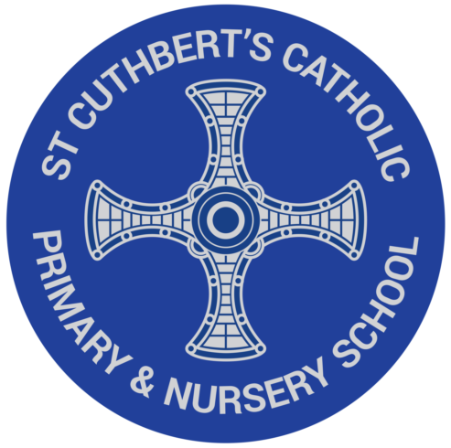
The Read Write Inc. Phonics programme
We are excited to introduce you to our new phonics programme at St. Cuthbert’s. The Ruth Miskin, Read Write Inc. programme teaches all children from Nursery upwards to learn to read with phonics.
Learning to read is the most important thing your child will learn at our school. Everything else depends on it, so we put as much energy as we possibly can into making sure that every single child learns to read as quickly as possible.
We want your child to love reading – and to want to read for themselves. This is why we put our efforts into making sure they develop a love of books as well as simply learning to read.
Children will be taught to ‘read’ the sounds in words and how those sounds can be written down. This is essential for reading, but it also helps children learn to spell well. We teach the children simple ways of remembering these sounds and letters.
The children also practise reading (and spelling) what we call ‘tricky words’, such as ‘once,’ ‘have,’ ‘said’ and ‘where’.

Homereading

We will only send home fully decodable books containing sounds and words they can read. Children will read the book three times in school and then again with you at home. Sometimes your child might bring home a picture book that they know well. Please don’t say, ‘This is too easy.’ Instead, encourage your child to tell you the story out loud; ask them questions about things that happen or what they think about some of the characters in the story.
We know parents and carers are very busy people. But if you can find time to read to your child as much as possible, it helps him or her to learn about books and stories. They also learn new words and what they mean. Show that you are interested in reading yourself and talk about reading as a family. You can find out about good stories to read to your child here: https://www.facebook.com/miskin.education

Does it matter if my child misses a lesson or two?
It matters a lot if your child misses school. The way we teach children to read is very well organised, so even one missed lesson means that your child has not learnt something that they need to know to be a good reader.

