2YO Home Learning
W/b 1-3-21 - Gospel Value – Trust & Justice

RE–Morning/Afternoon Prayer
‘Good morning Lord, we praise your holy name and thank you for giving us, this lovely new day’.
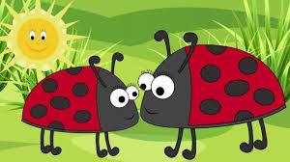
Communication and language - Introduce the
Nursery rhyme of the week called:
Ladybird, ladybird

Monday | Tuesday | Wednesday | Thursday | Friday
Communication and language –  Read or listen to the story,  Ginger bread man  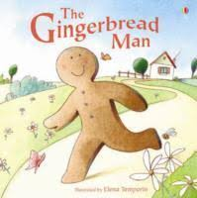 | Personal, social and emotional development-  Talk about the Gingerbread man and how your child thinks he is feeling. Ask your child how they think each of the characters feels within the story. | Physical Development –  Join in with on the farm yoga session | Communication and language –  World book Day  Read or listen to a story together. Maybe get your child to choose their favourite story. Ask them why they like that story so much. | Personal, social and emotional development-  Helping to clean. Give your child a duster or a cloth and allow them to help you clean up.  Children love to do ‘adult chores’ and this teaches them many things including respect for their home environment.
Monday | Tuesday | Wednesday | Thursday | Friday
Understanding the world-  Follow the link and listen to the sounds of the farm animals. Close your eyes, do you know who they belong too? | Expressive art and design-  Print out a template of a gingerbread man or draw one. Allow your child to decorate the man, encourage them to draw the face expressing a feeling. | Maths –  Colours, choose a selection of colours you believe your child knows and some that they may be unsure of. Use felt tips, crayons or pencils. Ask your child to find certain colours, they can put a little scribble on some paper of each colour. See how many they know. | Physical Development –  Act out a part of the story or pretend to be characters from within the book.  What would they do, say etc… | Expressive art and design –  Make some gingerbread men, you can use a cookie mix and just shape it into a men/women before baking or you can make real gingerbread.  Allow your child to get involved with the process as much a safely possible.

