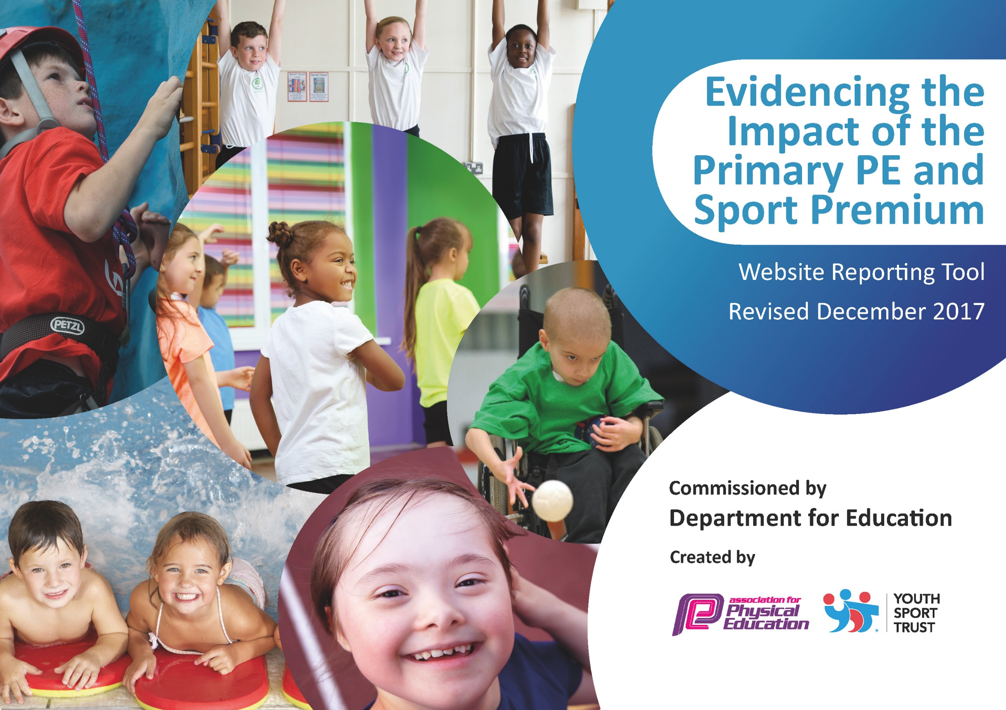

Schools must use the funding to make additional and sustainable improvements to the quality of PE and sport they offer. This means that you should use the Primary PE and Sport Premium to:

- develop or add to the PE and sport activities that your school already offers
- build capacity and capability within the school to ensure that improvements made now will benefit pupils joining the school in future years

Please visit gov.uk for the revised DfE guidance including the 5 key indicators across which schools should demonstrate an improvement. This document will help you to review your provision and to report your spend. DfE encourages schools to use this template as an effective way of meeting the reporting requirements of the Primary PE and Sport Premium.

We recommend you start by reflecting on the impact of current provision and reviewing the previous spend.
Under the Ofsted Schools Inspection Framework, inspectors will assess how effectively leaders use
the Primary PE and Sport Premium and measure its impact on outcomes for pupils, and how effectively governors hold them to account
for this.

Schools are required to publish details of how they spend this funding as well as on the impact it has on pupils’ PE
and sport participation and attainment.
We recommend regularly updating the table and
publishing it on your website as evidence
of your ongoing review into how you are using the money
to secure maximum, sustainable impact. To see an example of how to complete the table please click HERE.

Support for review and reflection - considering the 5 key indicators from DfE, what development needs are a priority for your setting and your students now and why? Use the space below to reflect on previous spend, identify current need and priorities for the future.

Key achievements to date: | Areas for further improvement and baseline evidence of need:
- Sporting facilities enhanced on St. Cuthbert’s new school site enabling the children to be more active during break / lunch times and have more space for physical activities.  - Subscribing to external providers to enhance provision and allow for competition across the city (LSSP / LDCSA / LPSAA).  - Monitoring the safety and relevance of equipment liaising with both staff and children to allow all to access the PE curriculum with confidence.  - Ensuring sports kit and transport are readily available to all children providing equal opportunity to succeed and take part in sporting activities around the city, both in and out of school time.  - Encouraging and providing opportunities for target groups to be aware of healthy lifestyles and the benefits of physical activity; building confidence to access a range of activities.  - Running of ESAA Badge Scheme (Athletics) which have allowed the children to set their own goals and targets against National standards.  - Maintaining Platinum School Games Awards / AfPE Award. | - To share the importance of PE upon returning to school for both the physical and mental wellbeing of our children.  - Continue to establish and review data for the five key indicators across the school.

Meeting national curriculum requirements for swimming and water safety | Please complete all of the below*:
What percentage of your current Year 6 cohort swim competently, confidently and proficiently over a distance of at least 25 metres? | Due to pool closures and COVID-19 children unable to swim.
What percentage of your current Year 6 cohort use a range of strokes effectively [for example, front crawl, backstroke and breaststroke]? | Due to pool closures and COVID-19 children unable to swim.
What percentage of your current Year 6 cohort perform safe self-rescue in different water-based situations? | Due to pool closures and COVID-19 children unable to swim.
Schools can choose to use the Primary PE and Sport Premium to provide additional provision for swimming but this must be for activity over and above the national curriculum requirements. Have you used it in this way? | Due to pool closures and COVID-19 children unable to complete ‘Top Up Swimming’ Courses.

Action Plan and Budget Tracking
Capture your intended annual spend against the 5 key indicators. Clarify the success criteria and evidence of impact that you intend to measure to evaluate for students today and for the future.

Academic Year: 2019/20 | Total fund allocated: £17,690  Funds transferred to new academic year: £2,085.98 (12%) |  |  | Date Updated: Summer Term
Key indicator 1: The engagement of all pupils in regular physical activity – Chief Medical Officer guidelines recommend that primary school children undertake at least 30 minutes of physical activity a day in school. |  |  |  |  | Percentage of total allocation:
 |  |  |  |  | £2287.91 – 13%
School focus with clarity on intended impact on pupils: | Actions to achieve: | Funding allocated: | Evidence and impact: |  | Sustainability and suggested next steps:
- Increase physical activity levels on the playground making use of new spaces with direction from PE Member of Staff. | - Mixed lunchtimes will enable KS1 & KS2 to play and learn together enabling older children to take on Sports Leader roles and participate / umpire games and mini challenges.  - LSAs to work alongside PE Member of Staff to promote active lunchtimes monitoring ‘sport zones’.  - Additional equipment to support active play / lunch times to enable children to try new activities and train for competitions independently fostering team spirit and leadership. | PE Staff  £2000  Equipment  £287.91 | - % of children active at both break and lunch times.  - Relationships between LKS2 and UKS2 strengthened through coaching and mentoring of games and activities – Pupil feedback / teacher observations.  - Incidents of behavior being monitored and recorded reduced – LSA.  - Pupils returning to class calm and ready to learn – Teacher / teaching assistant feedback. |  | - Sport to be used as an intervention tool, seek out CPD opportunities for staff to embed this into teaching timetable.

Key indicator 2: The profile of PE and sport being raised across the school as a tool for whole school improvement |  |  |  | Percentage of total allocation:
 |  |  |  | £1046.08 - 6%
School focus with clarity on intended impact on pupils: | Actions to achieve: | Funding allocated: | Evidence and impact: | Sustainability and suggested next steps:
- Raise the awareness of opportunities and the impact of physical activity and sports across the school and community with pupils and parents. | - Twitter / Class Dojo / Grid Maker: For all staff to take a whole school responsibility in promoting achievements / sporting opportunities available to the children within school and the local community.  - Weekly Assemblies: Sports leaders to share achievements and staff to present medals / certificates to highlight the progress made by the children in sport. Also provide opportunities for pupils to showcase their work through performance / LSSP live / recordings. | Medals & Certificates  £53.58 | - % of children graduating from sporting activities increased (St. Cuthbert’s Graduation).  - Parents invited to watch their children perform and celebrate their talents / receive award (Zoe Tynan Running Award – St. Cuthbert’s ‘first’) .  - Feedback from our school community through Twitter / Class Dojo posts celebrating the talents of our children. | - Maintain sporting rewards to boost the confidence of our children across all areas of the curriculum.  - Displays: To make prominent the children’s sporting achievements within our new school and show progression throughout the subject for our school community.
- To ensure ALL children receive  equal opportunities in  accessing PE and raising the profile of sport within our school. | - Minibus and coach hire to broaden the opportunities for all children to take part in sport (eg. transporting teams / KS2 annual park run).  - Fund Sports Kit and costumes (swimming, dancing and gymnastics) to enable children to participate and access all sporting opportunities within St. Cuthbert’s. | Transport  £145  Sports Kit  £847.50 | - % of children participating in PE lesson / extracurricular activities / competitive sport increased.  - Children accessing additional sporting opportunities to further develop their potential - football, dance and basketball. | - Continue to provide the essentials in order to allow ALL children to be physically active.

Key indicator 3: Increased confidence, knowledge and skills of all staff in teaching PE and sport |  |  |  | Percentage of total allocation:
 |  |  |  | £4100 - 23%
School focus with clarity on intended  impact on pupils: | Actions to achieve: | Funding  allocated: | Evidence and impact: | Sustainability and suggested  next steps:
- PE Member of Staff to ensure high quality teaching of physical activity as well as CPD of school staff. | - Employment of PE Member of staff to provide continuous professional development for staff.  - PE Member of Staff working closely alongside PE coordinators, teaching members of staff / learning support staff / lunchtime supervisors. | PE Staff  £4,000 | - Children receiving highly effective physical education lessons throughout the school in both indoor and outdoor PE, resulting in all children making good progress – Marking, Feedback and Assessment Overviews.  - Professional relationships strengthened so all classes have the best possible PE experiences and the continuity of provision enables all children to be challenged appropriately. | - Staff maintaining high standards of PE teaching across all key stages.  - PE Coordinators to continue to seek out courses / opportunities for staff to further educate and up-skill in delivering the PE curriculum.
- Receive updates and with regards to OfSTED framework and ‘deep dives’ in line with National Curriculum guidance ensuring school PE curriculum provision is of expected standard for our children. | - Attendance of practical based sessions for coordinators within the city to share practice and ideas with regards to the effective delivery of a skills based curriculum and implementing this within lessons.  - PE Coordinators to disseminate information to SMT and ensure provision is monitored and improved.  - Consistency of subject monitoring thoroughly and across all years groups providing constructive feedback via subject reports. | Staff CPD: Courses  £100 | - Increased independence of staff in effective delivery of the PE curriculum.  - Children’s comments reflective of positive physical / sporting experiments within their lessons. | - PE Coordinators to seek out courses / opportunities for staff to further educate and up-skill in delivering the PE curriculum.
Key indicator 4: Broader experience of a range of sports and activities offered to all pupils |  |  |  | Percentage of total allocation:
 |  |  |  | £3908.96 – 22%
School focus with clarity on intended  impact on pupils: | Actions to achieve: | Funding  allocated: | Evidence and impact: | Sustainability and suggested  next steps:
- To make use of new facilities with quality equipment  to widen the range of opportunities available to our children. | - Broaden the range of activities offered to the children to compete against other schools or to provide a challenge / new experience for them.  - Opportunities for vulnerable / talented pupils to engage in sporting activity that caters to their abilities. | Equipment  £500 | - Increased numbers of children engaging in alternative sports and competition.  - Children independently seeking out alternative sports which interest them and increase their physical activity levels. | - Sport to be used as an intervention tool, seek out CPD opportunities for staff to embed this into teaching timetable.
- To support international sporting opportunities for KS2 children which fosters holistic development. | - Provide opportunities to prepare the children enabling them to trial and practice new skills in a comfortable environment.  - Additional skiing tuition to ensure a safe and enjoyable experience for all children supporting and challenging their ability. | Skiing  Tuition  £3408.96 | - Children challenged at their ability to ensure an enjoyable experience.  - Fostering independence and providing unique opportunities to try new sports away from home.  - Positive feedback from children and families commenting on memorable sporting experiences. | - Seek out additional opportunities for children to develop sporting skills as well as promoting physical and mental wellbeing.
Key indicator 5: Increased participation in competitive sport |  |  |  | Percentage of total allocation:
 |  |  |  | £4261.07 – 24%
School focus with clarity on intended  impact on pupils: | Actions to achieve: | Funding  allocated: | Evidence and impact: | Sustainability and suggested  next steps:
- To allow ALL children to engage within competitive sports (inter / intra). | - Affiliation to competitive sport associations: LSSP, LDCSA, LPSAA.  - To plan and link activities in extracurricular timetable to citywide competition programme.  - Seek out opportunities for ALL children to engage in competitive sport (eg. Boccia / AG&T workshops). | Affiliation Fees  LSSP - £1775  LDCSA - £360  LPSAA - £200  AfPE - £93  Competition Sundries  £483.07 | - Increased % of children graduating at Summer ceremony through sporting activities.  - B & C Teams provided with opportunities to compete at various levels. | - Liaise within the community and through affiliations to network seeking out additional competitive opportunities.
- To foster the children’s sporting interests and promote a variety of sports. | - Appointment of qualified Basketball coaches to offer new sporting opportunities and train children for competitions. | Mersey Mavericks  £1350 | - Y5/6 Basketball Team - County Champions.  - Children scouted / selected to attend training sessions for city team.  - Enjoyment, pride and positive sporting memories created for our children and staff team, putting our school on the sporting map.  - Pupils seeking community Basketball teams to train with and represent, to further their talent and enjoyment of the sport.

