St. Cuthbert’s Catholic Primary

& Nursery School

**Motto**

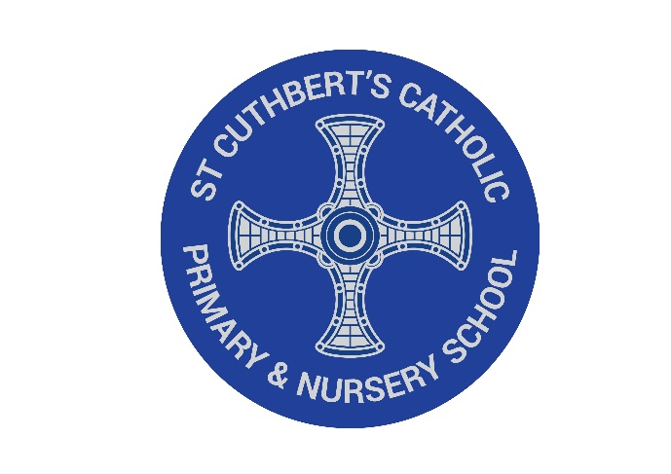

In love with Christ:

Be the best I can.

Be kind to one another.

Amen

St. Cuthbert’s Catholic Primary

& Nursery School

**Our Mission Statement**



We the pupils, parents, and staff of St Cuthbert’s strive to create a caring, educational community where; Christian principles and standards are upheld, each person is valued and the spiritual, aesthetic and moral growth of individuals, as well as their intellectual and physical needs are met.