Welcome to
St Cuthbert’s Catholic Primary And Nursery School

Foundation 2 to Year 1
Transition

St. Cuthbert’s Catholic Primary
School And Nursery

Our Mission Statement

We the pupils, parents, and staff of St Cuthbert’s strive to create a caring, educational community where; Christian principles and standards are upheld, each person is valued and the spiritual, aesthetic and moral growth of individuals, as well as their intellectual and physical needs are met.

Contact Details
Address: St Cuthbert’s Catholic Primary School 30 Church Road Liverpool L13 2BA
Telephone Number: 0151 228 4137 (School Office)
Email address: cuthberts-ao@st-cuthberts.liverpool.sch.uk
Website: www.stcuthbertsliverpool.co.uk/
Session Times: 8.55am – 3.05pm
Senior Leadership Team
Headteacher: Mrs Claire Bellis-Knox
Assistant Headteacher: Miss Angela Brough
Senior Teacher & SENCo: Mrs Kate Lunt
Learning Support Manager & DSL: Mrs Jackie Hilton
Business Manager: Mrs Lorraine Fay
Year 1 Team
Class Teacher:
Teaching Assistant:

Attendance
Every child has the right to attend school every day. Frequent and unnecessary absence has a detrimental effect on children’s academic education and social and emotional development. The expected level of attendance nationally is 97% and above. Our schools target is to exceed 98.9%. Attendance levels that fall below 95% are considered to be a cause for concern and will be referred to the Education Welfare Service for investigation.

Everyone associated with our federation has the responsibility to ensure that our children attend school regularly. We operate a First Response System where we will telephone you if we are not informed of the reasons your child is absent. Our school Attendance Officer will monitor registers across both sites every day and may visit the homes of those children who are absent without explanation. The Education Welfare Office will monitor the attendance of children. Those whose attendance falls below 90% are considered to be persistent absentees and may be subject to a penalty notice.

Please make sure that:-
- Your child attends school regularly and on time.
- You contact school by 9.15am if your child is too sick to come to school. The contact number is 0151 228 4137
- You are able to provide proof of illness if your child is absent. This could be a Doctors’ note, medicine bottle with your child’s name on it or copy of a prescription.
- You keep school informed (in confidence) if there are difficult circumstances at home.
- You should keep your contact details up to date in the school office.
- You make dental/medical appointments outside school time if possible otherwise appointment letters and cards must be shown to school.
- You DO NOT TAKE HOLIDAYS IN TERM TIME. Parents who take children on holiday in term time will receive a fine from the Local Authority.
- You help school in our aim to improve attendance.

The school will:
- Inform parents regularly if their child’s attendance is giving cause for concern.
- Aim to support families who are experiencing difficulties.
- Refer families requiring support to the Education Welfare Officer.
- Inform the Education Welfare Officer of any pupil absent for five or more school days. If there are safeguarding issues this will be two days.
- Invite parents/pupils to meet with governors to formally agree improvements in the form of a contract.
- Use Penalty Notices via Education Welfare when necessary.
- Delete a child’s name from the school register only when it is clearly known that the child has moved to another school. This must be confirmed by the receiving school.
- Challenge the parents of those children in Foundation 1 who have poor attendance. These parents may be asked to reconsider their place in the unit.
- Promote the importance of good attendance.
- Recognise and reward good attendance throughout the school with weekly assemblies, termly and annual prizes, medals and certificates.

Medication

If your child requires medication during school hours, a Senior Member of Staff will oversee the administration of it but it must be prescribed by a doctor and have a label stating:
- Child’s name
- Date
- Expiry Date
- Dose
- Frequency
An adult must hand the medication to an adult. Please DO NOT leave medication of any kind in the possession of our child.

Please complete the Pupil Medical and Welfare Form

Home Time

Please collect your child from the Infant Yard gate. Please be patient as children will be released to parents one at a time ensuring a safe handover. Please ensure that the person collecting your child is aged 16 or older and has been included on your Data Collection Form. If in the case of an emergency an adult (other than those listed on your Data Collection form) are required to collect your child, please ring the school office with their name, their relationship to your child and a password that they will be asked for upon collection of your child. If the person collecting is unable to recall the password, we will call you for verbal authorisation.

Please keep us updated of:
- Change of address or telephone number, in particular mobile phone numbers.
- Changes to the named people on the collection form.
- Change of emergency contact numbers.

Academic Year 2020/2021

Autumn Term 2020
- Starts: Tuesday 1st September (Inset Day children return Wednesday 2nd September)
- Ends: Friday 18th December
- Half term: Monday 26th to Friday 30th October
- Christmas break: Monday 21st December to Friday 1st January

Spring Term 2021
- Starts: Monday 4th January
- Ends: Friday 26th March
- Half term: Monday 15th to Friday 19th February
- Easter break: Monday 29th March to Friday 9th April

Summer Term 2021
- Starts: Monday 12th April
- Ends: Tuesday 20th July
- May day: Monday 3rd May
- Half term: Monday 31st May to Friday 4th June
195 DAYS WITH 5 INSET DAYS TO BE SET

Curriculum
English Curriculum
In KS1 we follow a text based approach to learning in which we use high quality texts to motivate and engage our children in their reading and writing. Our lessons provide many opportunities for learning and practice of basic skills such as: word reading, comprehension, grammar, punctuation, vocabulary and spelling. There are also regular sessions planned for guided reading to allow children to encounter further engaging texts and broaden their reading experience. Below is an example of the types of genres that will be covered in Year 1.

Maths Curriculum

In Year 1 we follow the SIL plans for the sequence of maths learning throughout the year. The children will continue to build on their skills and knowledge from Foundation and will also cover a variety of mathematical concepts throughout the year.

Foundation Subject Curriculum

We provide an exciting, stimulating curriculum which is vocabulary rich. Our curriculum covers a wide variety of topics and skills. We have a vocabulary rich curriculum and focus on building on children’s knowledge as they progress through the school. Below is an example of the topics Year 1 will be exploring throughout the year.
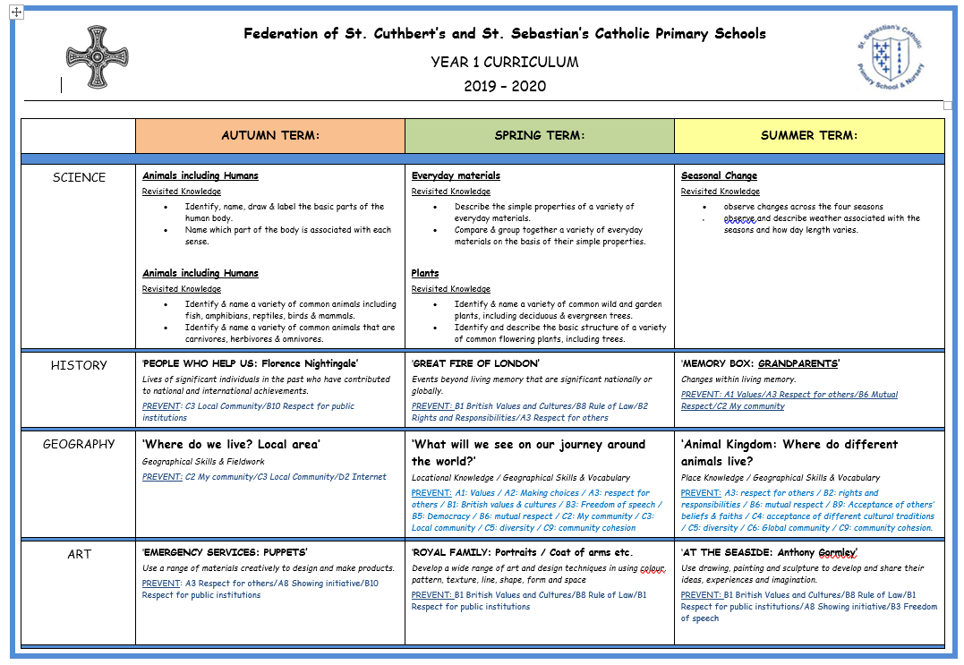

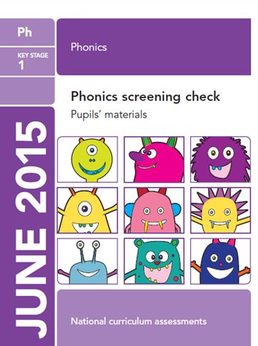
Phonics

Year 1 will continue with building on their Phonics skills from Foundation with daily grouped Phonics sessions to develop their early reading and writing skills. The Phonics Screening Check takes place for Year 1 children in June.

Year 1 Common Exception Words & Teddy Bear Words

Year 1 have a statutory list of spellings that all children must be able to read and write by the end of the year.
These are commonly referred to as Common Exception Words as children aren’t able to apply phonological knowledge to read and write these words. We support the learning of these words through our English Curriculum and also with the use of ‘Teddy Bear Words’ which are sent home weekly. These are then checked within school and when children can accurately read and spell the words on their given card, they will move on to a new word list. You may wish to begin to practice these words with your child before they start Year 1.
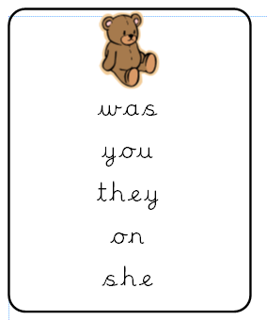

Homework
Children in Year 1 will begin receiving homework weekly, this may be in the forms of an English, Maths or spelling task. Homework is given out on a Friday and is to be returned completed on a Thursday in preparation for the next piece of homework to be given out. Please encourage your children to remember to return their homework promptly and completed. Spelling tests will normally take place on a Friday morning.

Book Bags and Home Reading

It is important that books bags are brought to school every day. Letters, homework, home reading books will be placed in these throughout the week. Children will read in school but it is also important that they continue this reading at home. Home reading books will be changed at least twice a week and we ask that parents comment on their child’s reading at home in their reading record book. We follow a three step process using your child’s home reading book:
  - Read book for pleasure.
  - Read for discussion.
  - Comprehension-establish your child’s understanding.

Children will also be given a phonetically decodable reading book which will match the sounds they have been learning in their daily phonics lessons.

It is essential that your child reads with you every day. This can be; reading bed time stories together, reading comics, menus, newspaper articles, reading and writing shopping lists, environmental texts etc. Please remember that your local library is a free, fantastic and exciting resource to promote reading with your child.

School Uniform
The wearing of school uniform helps the pupils establish a sense of identity with specific groups of people; furthermore conforming to school uniform regulations helps sustain the principle of self-discipline. Parents are asked to make every effort to ensure that the correct uniform is worn on all school occasions by all children from Foundation to KS2. Well presented, smart children feel proud of their uniform and school identity. They are ready and focused for leaning; they enjoy being in school and work well.

Y1-6 Girls- Winter
School uniform can be purchased from

Swan School Wear
13 Broadgreen Road
Liverpool
L13 5SD

PE kit and PE bag can be purchased from school office.

- Royal blue tartan kilt
- Royal blue jumper or cardigan with school logo
- White blouse
- School tie
- White/navy/black socks or tights
- Black school shoes (training shoes are not permitted)

Y1-6 Girls-Summer
- Royal blue gingham summer dress
- White socks
- Royal blue jumper or cardigan with school logo
- Black school shoes (training shoes are not permitted)

Y1-6 Boys Winter
- Black trousers
- Royal blue jumper or cardigan with school logo
- White shirt
- School tie
- Black school shoes (training shoes are not permitted)

Y1-6 Boys-Summer
- Pale blue polo shirt
- Black shorts (optional) or black trousers
- Royal blue jumper or cardigan with school logo
- Grey, white or black socks
- Black school shoes (training shoes are not permitted)

PE KIT – Girls and Boys
- Navy blue shorts with school logo
- Red t shirt with navy school logo
- Training shoes or pumps

Training shoes or pumps

Please ensure that your child’s PE kit is available every week in school for PE sessions. We recommend that children leave them in school during the week and they will be returned home each half term. It is a good idea
in preparation for Year 1 transition to practise getting dressed and undressed independently as Year 1 children are required to be as independent as possible in putting on their own PE kit.

Other Items

- Jewellery must not be worn for health and safety reasons.
- If your child has their ears pierced they must cover earrings with plasters.
- If hair is longer than collar length it must be tied back (girls and boys)
- Training shoes may be worn at play time and dinner time but must not be worn during class time.
- All children are welcome to wear jogging bottoms to and from school and at lunchtime if the weather is cold and may change in school.
- Extreme hair cuts are not permitted.

Please ensure that your child’s name is on all of their uniform, bags and lunch boxes

Toys, sweets or money

We ask that you do not allow your child to bring in any sweets or toys from home. These can become damaged or lost and this often causes the child unnecessary distress.

School Lunches

Parents who wish to change from school dinners or packed lunches must give the school office one weeks’ notice. If your child brings a packed lunch please ensure that you do not send in products containing nuts, chocolate coated biscuits, sweets, fizzy drinks or glass bottles. We are a healthy school. The children are encouraged to eat as much as possible of their savoury food before starting on any desserts so please ensure that portion sizes are appropriate.

Extra-Curricular Clubs

In Year 1, children are now eligible to stay for any extracurricular clubs which are available to their year group. Staff provide a wide variety of fantastic opportunities after school that your child can participate in. Clubs start straight after school and children are to be collected by 4pm. A timetable is issued each term with a new choice of clubs and will detail what days and clubs your child is able to stay for.

Class Dojo
After your child has moved into Year 1, they will be given a log in for our Class Dojo app which you can access from your mobile phone. This has proven an excellent way for parents to keep up to date with important information from school and you are able to connect with the class teacher directly. Teachers will strive to respond to any messages promptly however there may be a delay at times if they are teaching. They are only contactable during school hours, any messages sent outside of school hours will be answered during the next working day.

What we do to promote good home/school relationships:

- Newsletters – A newsletter will be sent home every half term to keep you informed of any events, activities, inset days etc.
- School Website – The school website contains information of any upcoming events, holiday dates or recent activities pertaining to the school. Each class has their own section and you can access information/photographs by clicking on the Foundation tab on the top right hand side of the screen.
- ClassDojo app - After your child has begun school, you will be given a log in for our classdojo app explaining how to access it on your phone. This has proven to be an excellent way for parents to keep up to date with what's going on and it allows you to contact their class teacher directly.
- St Cuthbert’s Twitter Account – please add @StCuthbertsPri on Twitter for up to date information and events happening daily in school. You can also download our school app for news, information, term dates, payments etc.
- Shared Learning Days – From time to time you will be invited into school to take part in a ‘shared learning day’. These days give you, the parents, the opportunity to observe firsthand what we do in the setting and allows you to ‘share’ in the learning experience with your child.
- Open evenings – Whilst you are welcome to access your child’s file of work at any time, we do allocate certain evenings during the term in which we invite you into the setting to peruse your child’s file of work and have a one to one chat with the Foundation staff regarding your child’s progress.
- Star of the Week – If your child is nominated as our class ‘Star of the Week’ they will be invited to take our ‘Star Teddy’ home to your house for the weekend. We ask that as parents you help your child to draw/ write what they did with ‘Star Teddy’ at the weekend and your child will be invited to share their news with the rest of the group the following Monday.

