Welcome to
St Cuthbert’s Catholic Primary And Nursery School

Early Years Foundation Stage
Foundation 2

St. Cuthbert’s Catholic Primary And Nursery School

Our Mission Statement

We the pupils, parents, and staff of St Cuthbert’s strive to create a caring, educational community where; Christian principles and standards are upheld, each person is valued and the spiritual, aesthetic and moral growth of individuals, as well as their intellectual and physical needs are met.

Contact Details
Address: St Cuthbert’s Catholic Primary And Nursery School 30 Church Road Liverpool L13 2BA
Telephone Number: 0151 228 4137 (School Office)
Email address: cuthberts-ao@st-cuthberts.liverpool.sch.uk
Website: www.stcuthbertsliverpool.co.uk/
Session Times: 8.55am – 3.05pm
Senior Leadership Team
Headteacher: Mrs Claire Bellis-Knox
Assistant Headteacher: Miss Angela Brough
Senior Teacher & SENCo: Mrs Kate Lunt
Learning Support Manager & DSL: Mrs Jackie Hilton
Business Manager: Mrs Lorraine Fay

Foundation Stage Team
EYFS Co-ordinator: Miss Angela Brough
Class Teacher: Miss Angela Brough
Nursery Nurse: Miss Pam Scrimshaw
Learning Support: Mrs Bernadette Sefton

Academic Year 2020/2021

Autumn Term 2020
- Starts: Tuesday 1st September (Inset Day children return Wednesday 2nd September)
- Ends: Friday 18th December
- Half term: Monday 26th to Friday 30th October
- Christmas break: Monday 21st December to Friday 1st January

Spring Term 2021
- Starts: Monday 4th January
- Ends: Friday 26th March
- Half term: Monday 15th to Friday 19th February
- Easter break: Monday 29th March to Friday 9th April

Summer Term 2021
- Starts: Monday 12th April
- Ends: Tuesday 20th July
- May day: Monday 3rd May
- Half term: Monday 31st May to Friday 4th June

195 DAYS WITH 5 INSET DAYS TO BE SET

Settling In Process
First Week

Your child will be allocated a morning or afternoon session for this week. The morning session will be from 8.55am-11.30am and the afternoon session will be from 12.30pm-3.05pm. These sessions give children the opportunity to develop relationships with staff and other children in the setting.

Second Week

Children will attend Foundation 2 for the whole day 8.55-3.05 and stay in school for lunch. Foundation 2 staff will accompany the children to the lunch hall each day until the children become familiar with the lunch time staff. If your child has any difficulties settling in, we will work with you and your child to devise a settling in plan to suit the needs of your child until he/she feel secure and settled in the unit.

What we do to help the Settling in Process

- Half day session – only fifteen children will attend each session throughout the first week, allowing for children to have the focused attention they may need.
- Each child will be given a ‘Key Person’ who will pay special attention to that child and do all they can to help them settle in. The ‘Key Person’ will speak to you, the parents, on a regular basis to keep you informed of your child’s adjustment to school life.
- Get to know your child and their interests so that we can plan activities which we think they will enjoy, thereby making his/her time in the unit as happy as possible so that they look forward to coming to school.
- Each session follows a similar routine so that the children adjust to school life as quickly as possible.

What you can do to help the Settling in Process

- Before your child starts school, talk to them about what will happen and show them the pictures from this booklet.
- Explain that they will be coming to school each day and that you will leave them to have fun with their friends and return to collect them at home time.
- Be patient with the settling in process, sometimes it may take longer than you had hoped.
- Please try to hide any anxieties you may have about leaving your child, as any upset you may express will result in further uncertainty for your child.
- Always collect your child on time, they will be waiting for you and may become anxious as they see other children being collected by their parents.

Daily Routine

8.55am: Self Registration
Children find their own name and write over the letters. This is to help them recognise and begin to write their name and also to inform staff of the attendance of children in school. [We do check this too!]

9.15am: Prayer & Circle Time
The children come together to sing a morning prayer, count the children, discuss the weather then follow an adult led input in accordance with the Early Years Foundation Stage Curriculum. This helps them to develop a level of concentration for a short period of time.

9.40am: Continuous Provision (Child Initiated Time)
This is the time of the day where the children choose what activities/resources they want to explore. It is during this time that practitioners observe and take time to extend the child’s skills and knowledge based on the child’s interests.

11.15 am: Phonics Session
Children follow the Letters and Sounds phonics scheme. A meeting will be held in October to give parents more information about introducing phonics.

11.45am: Key Person Time
Small group session following the children’s interests.

12.15-1.15pm: Lunch

1.15pm: Circle Time
Relaxation and breathing session followed by an adult led session in line with EYFS curriculum.

1.30pm: Continuous Provision (Child Initiated Time)
This is the time of the day where the children choose what activities/resources they want to explore. It is during this time that practitioners observe and take time to extend the child’s skills and knowledge based on the child’s interests.

2.50pm: Recall of the day, Story time and Prayer
Children come together to discuss learning that has taken place throughout the day. This helps them to self-evaluate, praise other children and make plans for the following day.

Home time – please collect your child at 3.05pm
Home Time
Please collect your child from the Foundation Stage Gate. Please be patient as children will be released to parents one at a time ensuring a safe handover. Please ensure that the person collecting your child is aged 16 or older and has been included on your Data Collection Form. If in the case of an emergency an adult (other than those listed on your Data Collection form) are required to collect your child, please ring the school office with their name, their relationship to your child and a password that they will be asked for upon collection of your child. If the person collecting is unable to recall the password, we will call you for verbal authorisation.

Please keep us updated of:
- Change of address or telephone number, in particular mobile phone numbers.
- Changes to the named people on the collection form.
- Change of emergency contact numbers.

Attendance
Every child has the right to attend school every day. Frequent and unnecessary absence has a detrimental effect on children’s academic education and social and emotional development. The expected level of attendance nationally is 97% and above. Our schools target is to exceed 98.9%. Attendance levels that fall below 95% are considered to be a cause for concern and will be referred to the Education Welfare Service for investigation.

Everyone associated with our federation has the responsibility to ensure that our children attend school regularly. We operate a First Response System where we will telephone you if we are not informed of the reasons your child is absent. Our school Attendance Officer will monitor registers across both sites every day and may visit the homes of those children who are absent without explanation. The Education Welfare Office will monitor the attendance of children. Those whose attendance falls below 90% are considered to be persistent absentees and may be subject to a penalty notice.

Please make sure that:-
- Your child attends school regularly and on time.
- You contact school by 9.15am if your child is too sick to come to school. The contact number is 0151 228 4137
- You are able to provide proof of illness if your child is absent. This could be a Doctors’ note, medicine bottle with your child’s name on it or copy of a prescription.
- You keep school informed (in confidence) if there are difficult circumstances at home.
- You should keep your contact details up to date in the school office.
- You make dental/medical appointments outside school time if possible otherwise appointment letters and cards must be shown to school.
- You DO NOT TAKE HOLIDAYS IN TERM TIME. Parents who take children on holiday in term time will receive a fine from the Local Authority.
- You help school in our aim to improve attendance.
- Inform parents regularly if their child’s attendance is giving cause for concern.
- Aim to support families who are experiencing difficulties.
- Refer families requiring support to the Education Welfare Officer.
- Inform the Education Welfare Officer of any pupil absent for five or more school days. If there are safeguarding issues this will be two days.
- Invite parents/pupils to meet with governors to formally agree improvements in the form of a contract.
- Use Penalty Notices via Education Welfare when necessary.
- Delete a child’s name from the school register only when it is clearly known that the child has moved to another school. This must be confirmed by the receiving school.
- Challenge the parents of those children in Foundation 1 who have poor attendance. These parents may be asked to reconsider their place in the unit.
- Promote the importance of good attendance.
- Recognise and reward good attendance throughout the school with weekly assemblies, termly and annual prizes, medals and certificates.

Medication
If your child requires medication during school hours, a senior member of staff will oversee the administration of it but it must be prescribed by a doctor and have a label stating:
- Child’s name
- Date
- Expiry Date
- Dose
- Frequency
An adult must hand the medication to an adult. Please DO NOT leave medication of any kind in the possession of our child. Please complete the Pupil Medical and Welfare Form

.
Foundation Stage Uniform
(available from Swan School Wear on Broadgreen Rd)

Winter Uniform
- Royal blue round neck sweatshirt with white stitched Foundation Unit
- Royal blue jogging bottoms
- White polo shirt
- Trainers or pumps with Velcro fastening (No Laces Please!)

Summer Uniform (optional)
- Royal blue shorts
- White polo top
- Trainers or pumps with Velcro fastening (No Laces Please!)
- Please note that due to the physical nature of the EYFS curriculum summer dresses are not permitted in the Foundation unit.
We also recommend that you leave a pair of wellington boots in the Unit for those muddy days.
Please ensure that your child’s name is on all of their uniform, bags and lunch boxes.

Snack Time
We provide a healthy snack each day and have a designated snack area. We ask for a voluntary contribution of £1 per week to cover the costs of snack. Thank you in advance for your support with this.

Toys, sweets or money
We ask that you do not allow your child to bring in any sweets, toys or money from home. These can become damaged or lost and this often causes the child unnecessary distress.
Jewellery
As a safety precaution, the wearing of chains, necklaces, earrings, bracelets and rings is forbidden in the Unit as such items can easily catch on equipment and cause injury.

What is the Early Years Foundation Stage (EYFS)?

The Early Years Foundation Stage is the framework all early years settings must follow. The framework provides guidance and information in relation to children’s learning, development and welfare. Characteristics of Effective Learning describes the ways in which the child engages with other people and their environment – playing and exploring, active learning, and creating and thinking critically. These characteristics underpin learning and development across all areas of learning and support the child to remain an effective and motivated learner.

Characteristics of Effective Learning:
Playing and exploring: children investigate and experience things and are willing to have a go.

Active learning: children concentrate and keep on trying when they encounter difficulties and enjoy their achievements.

Creating and thinking critically: children have and develop their own ideas, are able to make links between ideas and develop a range of strategies for doing things.

Play underpins the delivery of our Early Years Education, in which the children have the opportunity to play indoors and outdoors. As a Foundation team we carefully plan a curriculum following the children’s interests. We have a balance of planned adult directed activities and child initiated activities as well as a diversely stimulating environment in which the children can explore and develop their understanding within the different areas of learning.

EYFS Framework
The EYFS Framework identifies seven areas of learning and suggests that practitioners should focus heavily on what they term the ‘Prime Areas’. These prime areas (highlighted in Green) are Personal, Social and Emotional Development (PSED), Communication and Language (C&L) and Physical Development (PD). Whilst a strong emphasis is placed on these ‘Prime Areas’, we do also devise inputs and plan activities relating to what are deemed the ‘Specific Areas’ of learning (highlighted in blue).

Personal, Social and Emotional Development

Involves helping children to develop a positive sense of themselves, and others; to form positive relationships and develop respect for others; to develop social skills and learn how to manage their feelings; to understand appropriate behaviour in groups; and to have confidence in their own abilities.

PSED is made up of these aspects:

Self-confidence and self-awareness: children are confident to try new activities, and say why they like some activities more than others. They are confident to speak in a familiar group, will talk about their ideas, and will choose the resources they need for their chosen activities. They say when they do or don’t need help.

Managing feelings and behaviour: children talk about how they and others show feelings, talk about their own and others’ behaviour, and its consequences, and know that some behaviour is unacceptable. They work as part of a group or class, and understand and follow the rules. They adjust their behaviour to different situations, and take changes of routine in their stride.

Making relationships: children play co-operatively, taking turns with others. They take account of one another’s ideas about how to organise their activity. They show sensitivity to others’ needs and feelings, and form positive relationships with adults and other children.

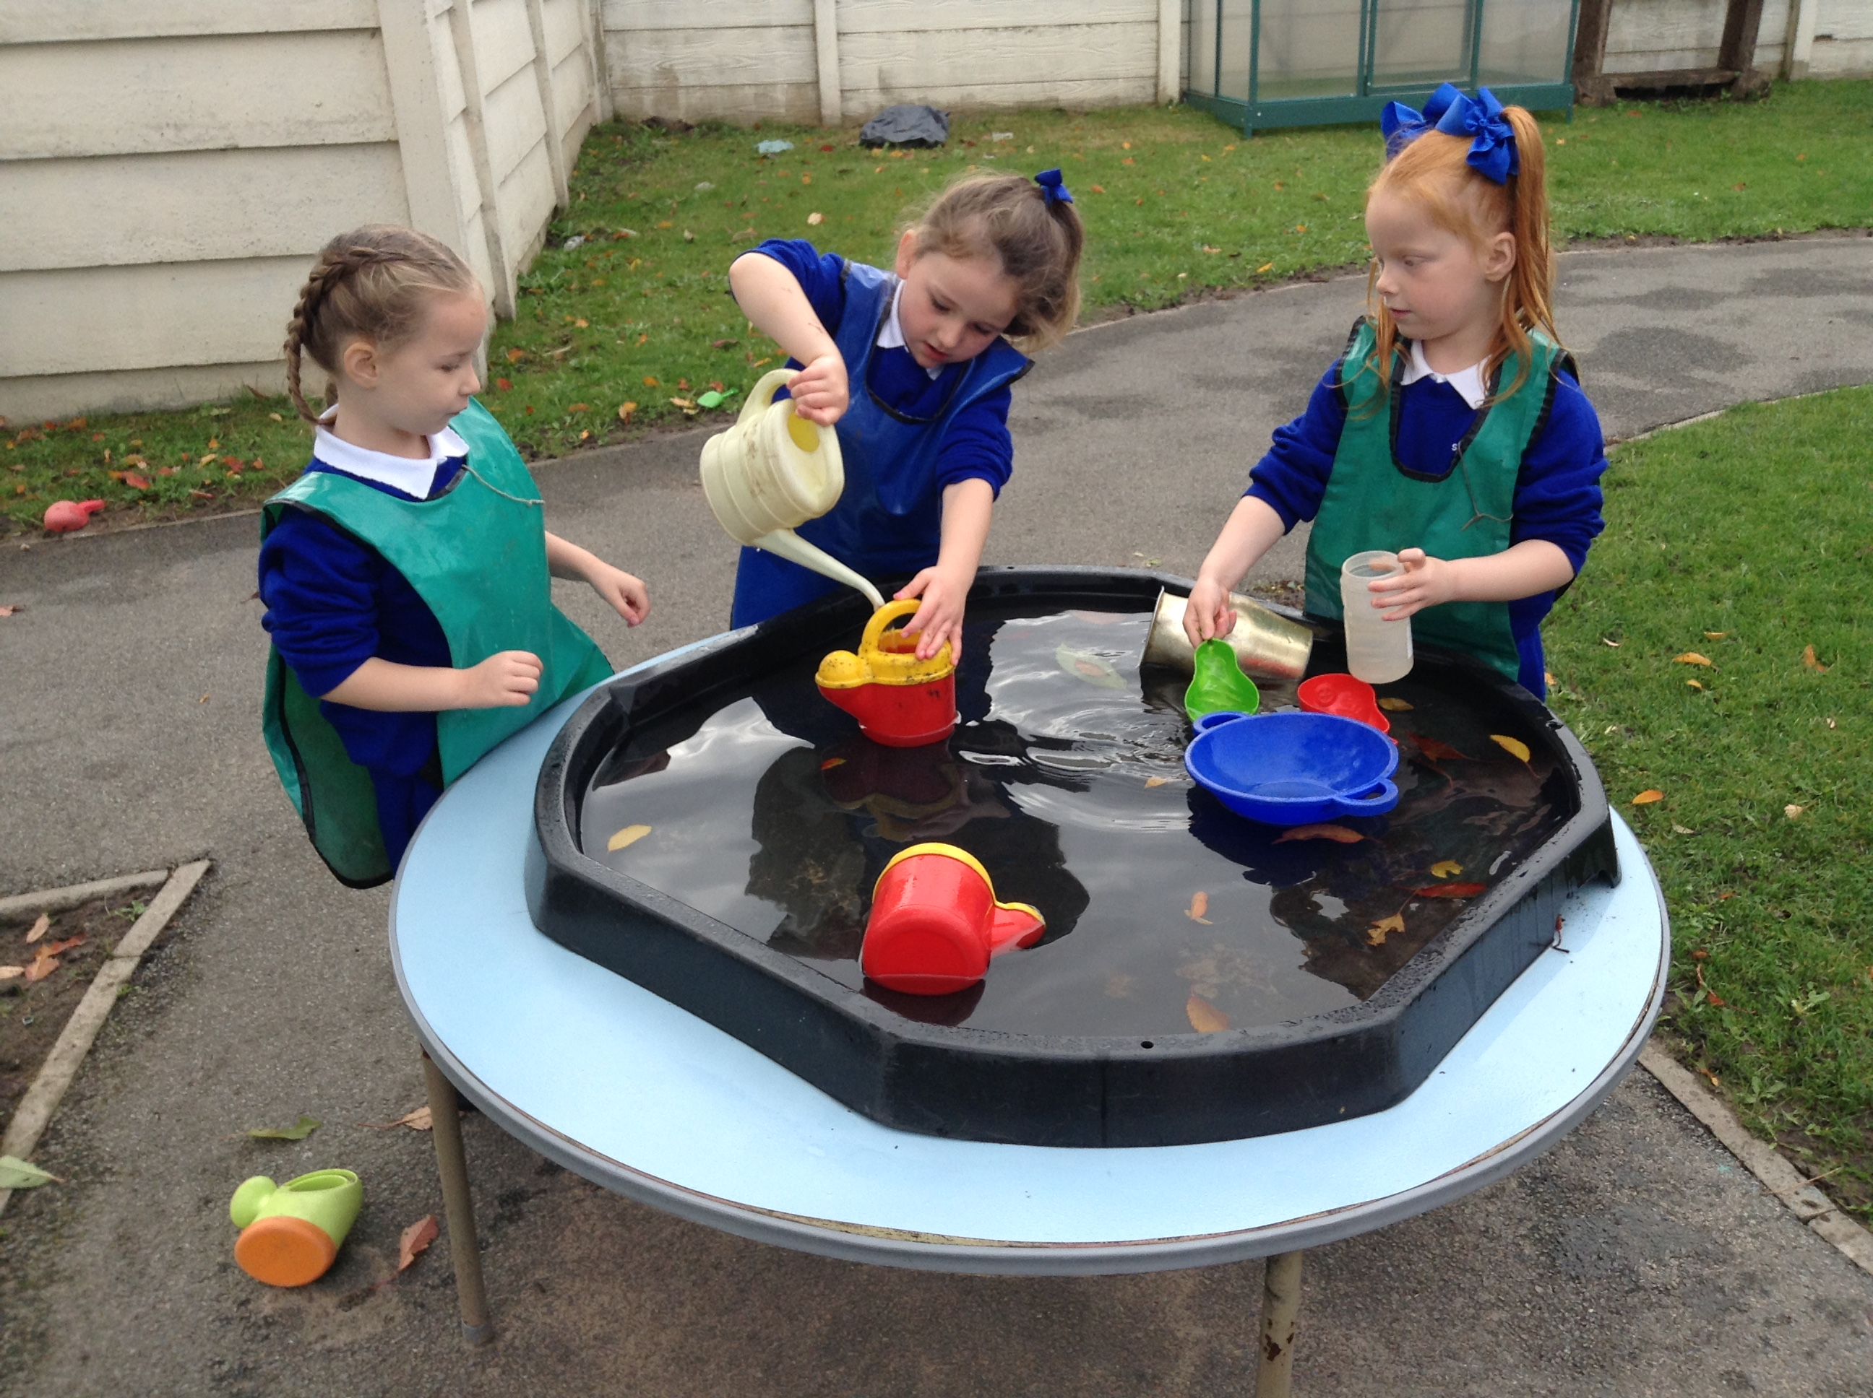

Communication and Language

Involves giving children opportunities to experience a rich language environment; to develop their confidence and skills in expressing themselves; and to speak and listen in a range of situations.

CL is made up of these aspects:

Listening and attention: children listen attentively in a range of situations. They listen to stories, accurately anticipating key events and respond to what they hear with relevant comments, questions or actions. They give their attention to what others say and respond appropriately, while engaged in another activity.

Understanding: children follow instructions involving several ideas or actions. They answer ‘how’ and ‘why’ questions about their experiences and in response to stories or events.

Speaking: children express themselves effectively, showing awareness of listeners’ needs. They use past, present and future forms accurately when talking about events

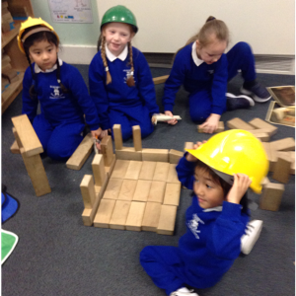

Physical Development

Involves providing opportunities for young children to be active and interactive; and to develop their co-ordination, control, and movement. Children must also be helped to understand the importance of physical activity, and to make healthy choices in relation to food, exercise and sleep.

PD is made up of these aspects:

Moving and handling: children show good control and co-ordination in large and small movements. They move confidently in a range of ways, safely negotiating space. They handle equipment and tools effectively, including pencils for writing.

Health and self-care: children know the importance for good health of physical exercise, and a healthy diet, and talk about ways to keep healthy and safe. They manage their own basic hygiene and personal needs successfully, including dressing and going to the toilet independently.

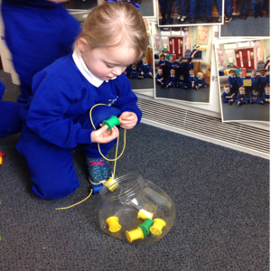

Literacy

Literacy development involves encouraging children to link sounds and letters and to begin to read and write. Children must be given access to a wide range of reading materials (books, poems and other written materials) to ignite their interest.

LD is made up of these aspects

Reading: children read and understand simple sentences. They use phonic knowledge to decode regular words and read them aloud accurately. They also read some common irregular words. They demonstrate understanding when talking with others about what they have read.

Writing: children use their phonic knowledge to write words in ways which match their spoken sounds. They also write some irregular common words. They write simple sentences which can be read by themselves and others. Some words are spelt correctly and others are phonetically plausible.

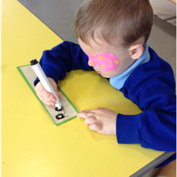
.

Mathematics

Involves providing children with opportunities to develop and improve their skills in counting, understanding and using numbers, calculating simple addition and subtraction problems; and to describe shapes, spaces and measures.

Mathematics is made up of these aspects:

Numbers: children count reliably with numbers from 1 to 20, place them in order and say which number is one more or one less than a given number. Using quantities and objects, they add and subtract two single-digit numbers and count on or back to find the answer. They solve problems, including doubling, halving and sharing.

Shape, space and measures: children use everyday language to talk about size, weight, capacity, position, distance, time and money to compare quantities and objects and to solve problems. They recognise, create and describe patterns. They explore characteristics of everyday objects and shapes and use mathematical language to describe them.

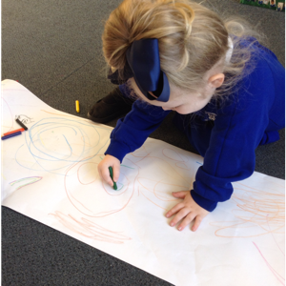

Understanding the World

Involves guiding children to make sense of their physical world and their community through opportunities to explore, observe and find out about people, places, technology and the environment.

UW is made up of these aspects:

People and communities: children talk about past and present events in their own lives and in the lives of family members. They know that other children don’t always enjoy the same things, and are sensitive to this. They know about similarities and differences between themselves and others, and among families, communities and traditions.

The World: children know about similarities and differences in relation to places, objects, materials and living things. They talk about the features of their own immediate environment and how environments might vary from one another. They make observations of animals and plants and explain why some things occur, and talk about changes.

Technology: children recognise that a range of technology is used in places such as homes and schools. They select and use technology for particular purposes.

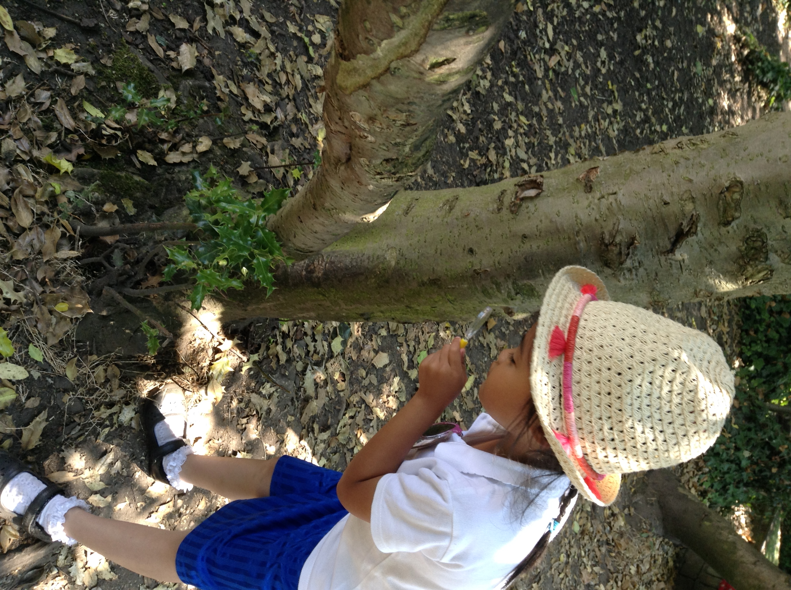

Expressive Arts and Design

Involves enabling children to explore and play with a wide range of media and materials, as well as providing opportunities and encouragement for sharing their thoughts, ideas and feelings through a variety of activities in art, music, movement, dance, role-play, and design and technology.

EAD is made up of these aspects:

Exploring and using media and materials: children sing songs, make music and dance, and experiment with ways of changing them. They safely use and explore a variety of materials, tools and techniques, experimenting with colour, design, texture, form and function.

Being imaginative: children use what they have learnt about media and materials in original ways, thinking about uses and purposes. They represent their own ideas, thoughts and feelings through design and technology, art, music, dance, role-play and stories.

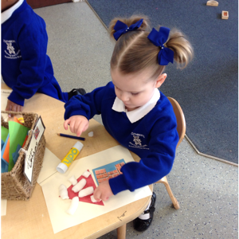

Key Person Role

We have a Key Person system in place which has proved to be extremely effective for all of the children and their families. Every child in nursery will have a Key Person. Your child will meet with their group regularly. During this time the children will be given the opportunity to reflect on their sessions work, share news, talk about special events that have happened, share a story or sing some songs/nursery rhymes. This also allows a smaller group of children to get to know each other better and also establish a closer relationship with their Key Person. If your child has done something special or would like to share something special please speak to your child’s Key Person who can share this at small group time.

There are also opportunities throughout the year to meet with your child’s Key Person to discuss your child’s progress. If you wish to speak to your child’s Key Person regarding something in particular please arrange an appointment through the office. In order to ensure child safety due to it being a busy time with children entering and leaving the unit at the beginning and end of their session, please be prepared to stand back and wait a few moments, staff will be unable to answer questions at this time. If you wish you may stand to one side until all of the children have been safely collected by their parents and then a member of staff will be able to help you. We do also use ClassDojo, this is an app that you can download onto your phone and message your child's teacher directly. Further information on how to do this will be given to you when your child starts nursery. The children call adults in the Foundation Unit by their first names.

We will strive to ensure good relations between ourselves and you in order to keep the lines of communications open at all times. We value your opinion, views and input as the child’s first educator, however should you have any concerns no matter how small please do not hesitate to speak to us to relieve any worries. Minor issues can usually be resolved by your child's teachers. If you do have any unresolved issues or complaints, please contact Mrs. C. Bellis-Knox or Jackie Hilton by phoning or writing to school.

Home/School Links

We recognise the importance of fostering a good relationship between us, the school, and you, the parents/guardians and we continually strive to ensure good relations between both parties. We value your opinion, views and input as your child’s first educator and think it best for all parties concerned if the lines of communication are open at all times. We therefore operate an ‘open door policy’ and suggest that if you do have any questions, queries or concerns, no matter how small, that you speak to a member of staff. We are always happy and willing to listen to you about any and all matters. Most issues can generally be dealt with by the Foundation staff however, if you have a complaint please contact Mrs C Bellis-Knox or Mrs J Hilton by phoning or writing to the school.

What we do to promote good home/school relationships

Newsletters – A newsletter will be sent home every half term to keep you informed of any events, activities, inset days etc.

School Website – (stcuthbertsliverpool.co.uk) The school website contains information of any upcoming events, holiday dates or recent activities pertaining to our school.

ClassDojo app - After your child has begun school, you will be given a log in for our classdojo app explaining how to access it on your phone. This has proven to be an excellent way for parents to keep up to date with what's going on and it allows you to contact their class teacher directly. Teachers will strive to respond to any messages promptly however there may be a delay at times if they are teaching. They are only contactable during school hours, any messages sent outside of school hours will be answered during the next working day.

St Cuthbert’s Twitter Account – please add @StCuthbertsPri on Twitter for up to date information and events happening daily in school. You can also download our school app for news, information, term dates, payments etc.

Shared Learning Days – From time to time you will be invited into the Unit to take part in a ‘shared learning day’. These days give you, the parents, the opportunity to observe firsthand what we do in the setting and allows you to ‘share’ in the learning experience with your child.

Open evenings – Whilst you are welcome to access your child’s file of work at any time, we do allocate certain evenings during the term in which we invite you into the setting to peruse your child’s file of work and have a one to one chat with the Foundation staff regarding your child’s progress.

Star of the Week – If your child is nominated as our class ‘Star of the Week’ he/she will be invited to take our ‘Star Teddy’ home to your house for the weekend. We ask that as parents you help your child to draw/ write what they did with ‘Star Teddy’ at the weekend and your child will be invited to share their news with the rest of the group the following Monday.

St. Cuthbert’s Home Visit Policy

Childhood experiences lay the foundations for later life. Parenting has a critical impact on children’s emotional, behavioural and educational development, and their health and wellbeing. The school works in partnership with parents to ensure positive outcomes for children and the first step in this partnership is to home visit every family prior to the child coming to nursery (Foundation 1).

Two members of staff from the Foundation Stage Unit will carry out these visits, one of whom will be your child’s allocated key worker or SMT. Both members of staff will wear their I.D badges and carry a mobile phone left on throughout the visit, the number of which will be left in the school office. The safety of our staff is paramount and an informal risk assessment is carried out before entering the home of the family.

The address of the home visit is always left in the school diary located in the school office; also a member of the SMT (Senior Management Team) is aware of the visit taking place.

The key-worker or SMT will take along a Foundation 1 handbook and share any relevant information with the parents/carers, a home visit record sheet is completed during the home visit. The key worker will explain the settling in period with the parent and will find out the child’s favourite toys, interests and any other relevant family background information.

A period of half an hour will be allocated to each home visit. As part of our induction to the Foundation Stage, a home visit is carried out, however if a home visit is unsuitable the parent will be invited to visit the nursery at a mutually agreed time to meet the child’s key worker. An agreed start date is given at the visit and parents are asked to stay for one hour on this visit to complete all necessary paper work and contact details.

The Lead Practitioner (Jackie Hilton) may also carry out additional home visits throughout the year, to support families with varying needs (throughout the year). If these visits are undertaken, the necessary safeguarding procedures are put in place.

