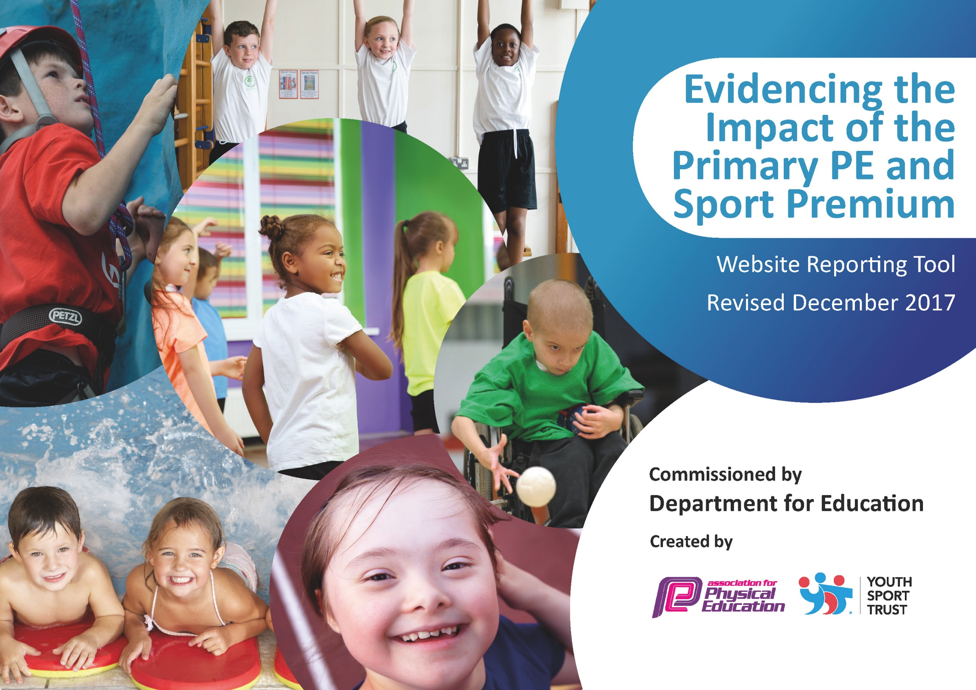

Schools must use the funding to make additional and sustainable improvements to the quality of PE and sport they offer. This means that you should use the Primary PE and Sport Premium to:

- develop or add to the PE and sport activities that your school already offers
- build capacity and capability within the school to ensure that improvements made now will benefit pupils joining the school in future years

Please visit gov.uk for the revised DfE guidance including the 5 key indicators across which schools should demonstrate an improvement. This document will help you to review your provision and to report your spend. DfE encourages schools to use this template as an effective way of meeting the reporting requirements of the Primary PE and Sport Premium.

We recommend you start by reflecting on the impact of current provision and reviewing the previous spend.
Under the Ofsted Schools Inspection Framework, inspectors will assess how effectively leaders use
the Primary PE and Sport Premium and measure its impact on outcomes for pupils, and how effectively governors hold them to account
for this.

Schools are required to publish details of how they spend this funding as well as on the impact it has on pupils’ PE
and sport participation and attainment.
We recommend regularly updating the table and
publishing it on your website as evidence
of your ongoing review into how you are using the money
to secure maximum, sustainable impact. To see an example of how to complete the table please click HERE.

Support for review and reflection - considering the 5 key indicators from DfE, what development needs are a priority for your setting and your students now and why? Use the space below to reflect on previous spend, identify current need and priorities for the future.

Key achievements to date: | Areas for further improvement and baseline evidence of need:
- Subscribing to external providers to enhance provision and allow for competition across the city (LSSP / LDCSA / LSFA / Bikeability).  - Working alongside Little Sports Coaches further enhancing staff CPD and facilitating physical activity during lunchtimes for ALL children.  - Maintain with Little Sports Coaches and EYFS to allow for a whole school approach and provide CPD for Early Years staff.  - Monitor the safety and relevance of equipment liaising with both staff and children to allow all to access the PE curriculum with confidence.  - Ensure sports kit and transport are readily available to all children providing equal opportunity to succeed and take part in sporting activities around the city, both in and out of school time.  - Encourage and provide opportunities for target groups to be aware of healthy lifestyles and the benefits of physical activity; building confidence to access a range of activities.  - Running of ESAA Badge Scheme (Athletics) which have allowed the children to set their own goals and targets against National standards.  - Launch and implementation of the BEE Netball Project with England Netball.  - Applying and maintaining Gold / Platinum School Games Awards. | - Continue to establish and review data for the five key indicators across the school.  - Continue to update equipment and liaise with LA in order to provide 30 minutes of activity each day to be carried out consistently across both KS1 & KS2 – Due to ongoing building work of St. Cuthbert’s new school making use of areas / zones to facilitate activity.

Meeting national curriculum requirements for swimming and water safety | Please complete all of the below*:
What percentage of your current Year 6 cohort swim competently, confidently and proficiently over a distance of at least 25 metres? | 30/30  100%
What percentage of your current Year 6 cohort use a range of strokes effectively [for example, front crawl, backstroke and breaststroke]? | 19/30  63%
What percentage of your current Year 6 cohort perform safe self-rescue in different water-based situations? | 29/30  96%
Schools can choose to use the Primary PE and Sport Premium to provide additional provision for swimming but this must be for activity over and above the national curriculum requirements. Have you used it in this way? | Yes  Top – Up Swimming  6/30 required  6/6 passed  1 week intense course

Action Plan and Budget Tracking
Capture your intended annual spend against the 5 key indicators. Clarify the success criteria and evidence of impact that you intend to measure to evaluate for students today and for the future.

Academic Year: 2018/19 | Total fund allocated: £17,671 | Date Updated: 19/07/2019
Key indicator 1: The engagement of all pupils in regular physical activity – Chief Medical Officer guidelines recommend that primary school children undertake at least 30 minutes of physical activity a day in school |  |  |  | Percentage of total allocation:
 |  |  |  | 20%
School focus with clarity on intended impact on pupils: | Actions to achieve: | Funding allocated: | Evidence and impact: | Sustainability and suggested next steps:
- Ensure ALL children are receiving the opportunity to undertake at least 30 minutes of physical activity in the school day. | - Identification of target groups to ensure all children are physically active for 30 minutes per day.  - Set-up lunchtime clubs (eg. Fitness is Fun) to be run by TA’s and Teachers in order to promote physical fitness. | Staff CPD  £1000 | - 100% of children seeking opportunities to participate in physical activity.  - Children to appreciate the importance of physical fitness on a healthy, balanced lifestyle – pupil & teacher feedback. | - Targeted groups to independently seek out active opportunities.  - Promote out of school activities to sustain and further improve physical fitness eg. Walking / riding bikes to school.  - Promote community /club links for children to pursue hobbies.

- Increase physical activity levels on the playground through the training of LSAs (Lunchtime Supervisors) and Young Leaders Programme. | - Train Year 6 cohort to deliver active games with the children in lower Key Stages.  - LSAs to work alongside coaching staff (Little Sports) as CPD development in order to promote active lunchtimes monitoring ‘sport zones’.  - Additional equipment to support the active pay / lunch times to enable children to try new activities. | Little Sports  £1,500  Equipment  £1000 | - % of children active at both break and lunch times.  - Relationships between LKS2 and UKS2 to develop through coaching and mentoring of games and activities – Pupil feedback / teacher observations.  - Incidents of behavior being monitored and recorded to be reduced – LSA.  - Pupils returning to class calm and ready to learn – Teacher / teaching assistant feedback. | - Sport Leaders to attend / give advice to School Councilor with regard to the success of active break and lunchtimes.  - Reward systems to be put into place by both lunchtime staff & sports leaders.
Key indicator 2: The profile of PE and sport being raised across the school as a tool for whole school improvement |  |  |  | Percentage of total allocation:
 |  |  |  | 10%
School focus with clarity on intended impact on pupils: | Actions to achieve: | Funding allocated: | Evidence and impact: | Sustainability and suggested next steps:
- Opportunities for children to achieve National Accredited Levels of Achievement within a variety of sports. | - Opportunities for the children to achieve badges have been created through PE lessons, extra -curricular clubs and also through competitions. The children use their personal best in order to acquire the badges.  - The school now has the ESSA badge scheme up and running for KS 2 pupils. This is used in both indoor and outdoor athletics.  - The awards are displayed so the children can self –check their progress. | Badge Scheme  £200 | - Presenting badges in assembly has enabled whole school recognition of the children’s achievement and allowed them to be proud of what they can achieve compared to a national scale.  - The profile of athletics has been raised within the school, as the children compete not only against each other but also against themselves seeking advice to develop techniques to further their progress in PE. | - Expansion of awards across other sports (eg. Netball / Gymnastics & Swimming).
- Raise the awareness of opportunities and the impact of physical activity and sports across the school and community with pupils and parents. | - Twitter: For all staff to take a whole school responsibility in promoting achievements / sporting opportunities available to the children within school and the local community.  - Displays: To make prominent the children’s sporting achievements within our school and feedback on sporting opportunities sharing pupil voice. Notice boards also to share upcoming sporting events / opportunities. Badge Schemes displayed to provide children with a sense of achievement and give them future targets.  - Weekly Assemblies: Sports leaders to share achievements and staff to present medals / certificates / progress made by the children in sport. Also provide opportunities for pupils to showcase their work through performance / LSSP live / recordings. | Medals & Certificates  £500 | - % of children graduating from sporting activities to increase.  - 100% of children involved in weekly assemblies to celebrate PE and Sport.  - Parents invited to watch their children perform and celebrate their talents. | - Continue to share and celebrate school sport.
- To ensure ALL children receive  equal opportunities in  accessing PE and raising the profile of sport within our school. | - Minibus and coach hire to broaden the opportunities for all children to take part in sport (eg. transporting teams / KS2 annual park run).  - Fund Sports Kit and costumes (swimming, dancing and gymnastics) to enable children to participate and access all sporting opportunities within St. Cuthbert’s.  - Provide funds / donations towards the children outside sporting opportunities (eg. County Level Football / Dance World Cup). | Transport  £500  Sports Kit  £350  Funding  £300 | - % of children participating in PE lesson / extracurricular activities / competitive sport to increase.  - Children to access additional sporting opportunities to further develop their potential. | - Continue to provide the essentials in order to allow ALL children to be physically active.

Key indicator 3: Increased confidence, knowledge and skills of all staff in teaching PE and sport |  |  |  | Percentage of total allocation:
 |  |  |  | 50%
School focus with clarity on intended  impact on pupils: | Actions to achieve: | Funding  allocated: | Evidence and impact: | Sustainability and suggested  next steps:
- Implementation of Specialists Physical Education Coaches to ensure high quality teaching of physical activity as well as CPD of school staff. | - Employment of Little Sports coaches provides continuous professional development for staff.  - Little Sports work closely alongside PE coordinators, teaching members of staff / learning support staff / lunchtime supervisors.  - Little Sports have worked alongside the school to ensure consistency in assessment of PE throughout the whole school  - Establish links with specialist teachers (eg. Secondary School) to support in the facilitation of PE and sports within the curriculum. | Little Sports  £7,500 | - Securing confidence in staff to maintain high standards of teaching in all who lead and support within the teaching of PE.  - Children receive highly effective physical education lessons throughout the school in both indoor and outdoor PE resulting in all children making good progress regardless of their level / ability – PE Assessment Tracker.  - Professional relationships to ensure that all classes have the best possible PE experiences and the continuity of provision enable the children to be challenged appropriately. | - Staff questionnaire to identify any areas of the curriculum which may need additional support.  - PE Coordinators to seek out courses / opportunities for staff to further educate and up-skill in delivering the PE curriculum.
- Update and implement new OfSTED framework in line with National Curriculum guidance a progressive curriculum that all staff are confident in delivering. | - PE Coordinators to identify gaps within curriculum knowledge.  - PE Coordinators to allow observations / team teaching of the PE curriculum to support the development of staff.  - Consistency of subject monitoring thoroughly and across all years groups providing constructive feedback to staff members. | Staff CPD: Courses  £1,000  Val Sabin support materials:  £300 | - Increased confidence levels of staff in delivering curriculum.  - A whole school approach in growing expertise to apply across the curriculum to provide a collective responsibility of PE amongst staff. | - Staff questionnaire to identify any areas of the curriculum which may need additional support.  - PE Coordinators to seek out courses / opportunities for staff to further educate and up-skill in delivering the PE curriculum.
Key indicator 4: Broader experience of a range of sports and activities offered to all pupils |  |  |  | Percentage of total allocation:
 |  |  |  | 7%
School focus with clarity on intended  impact on pupils: | Actions to achieve: | Funding  allocated: | Evidence and impact: | Sustainability and suggested  next steps:
- To widen the range of opportunities to the children by including other areas of activity not currently covered in the curriculum e.g. outdoor and adventurous activities / SEN / AG&T. | - Broaden the range of activities offered to the children to other compete against other schools or to provide a challenge / new experience for them.  - Liaise with external sporting providers to introduce new sports to the children (eg. Basketball).  - Opportunities for vulnerable / talented pupils to engage in sporting activity that caters to their abilities (eg. WESPA / Boccia). | Equipment  £500  Mersey Mavericks  £550 | - Numbers of children engaging in alternative sports and competition to increase.  - Children to independently seek out alternative sports which interest them and increase their physical activity levels. | - Pupil / Sports Leaders questionnaires to advise staff and PE coordinators of the children’s interest to pursue.
- To facilitate national / international sporting events that capture the imagination of pupils and link it to our school sports programme. | - Purchase of tickets / transport to visit local  M&S Bank Arena.  Netball World Cup 2019 & British Gymnastics Festival | Tickets  £200  Transport  £50 | - Widening experiences for children in their home city in relation to sport.  - Feedback from children in relation to events / families purchasing tickets to attend. | - Pupils engaging in and following up new sporting activities to try to encourage long-life participation in sport.
Key indicator 5: Increased participation in competitive sport |  |  |  | Percentage of total allocation:
 |  |  |  | 13%
School focus with clarity on intended  impact on pupils: | Actions to achieve: | Funding  allocated: | Evidence and impact: | Sustainability and suggested  next steps:
- To allow ALL children to engage within competitive sports (inter / intra). | - Affiliation to competitive sport associations: LSSP, LADCSA, LPSAA, LSFA.  - To plan and link activities in extracurricular timetable to citywide competition programme.  - Seek out opportunities for ALL children to engage in competitive sport (eg. Boccia / AG&T workshops).  - Opportunities for increased participation in intra-sports competitions through the Federation. | Affiliation Fees  LSSP  £1650  LDCSA  £360  LPSAA  £200  Wavertree Track Hire  £250 | - Increased number of children entered into B & C teams to compete.  - ALL children from target groups to be given opportunities to compete.  - Increased % of children graduating through Children’s University system within sporting activities. | - Liaise within the community and affiliations to network and seek out additional competitive opportunities.

